|  |  |
| --- | --- |
| PROG7311  Task 2 / POE Documentation | Application ACME  Application ID: ACME023  Version: 1.23  Student Name: Karl Dicks  Student Number: 17667327  Course: BCAD3  Subject: PROG7311  Lecturer: Nirasha Ramckurran  Assignment: Task 2  Due Date: 31/08/2020 |

Contents

**Introduction** 1

**Overview** 3

**Help File** 5

**Readme** 11

**Screenshots** 14

**Database Entities** 40

**Use Case Diagram** 44

**Conclusion** 45

**References** 46

# **Introduction**

As part of our PROG7311 module, we were tasked with developing an e-commerce web application in the ASP.NET Core framework. I chose to develop the application in C#, using the Visual Studio 2019 IDE, as we were familiar with this IDE from other programming modules. My application is backwards compatible with Visual Studio 2017 – as it uses ASP.NET Core 2.1, which is compatible with both 2017 and 2019 versions of Visual Studio. There were a number of requirements that the application had to perform, which have been implemented on the website, using suitable design and architecture patterns. (The Independent Institute of Education, 2020)

The e-commerce web application allows users to perform multiple actions, including:

* **Register and login**The web application allows the user to register an account with their own preferences, and log in. User profiles are stored in a local MSSQL MDF file, along with products, categories, and other information used by the website. This can easily be migrated to an online Azure database when it is published.  
  Due to the website requiring two different roles – customer and admin, a default administrative account has been set, which can assign and revoke privileges for other signed-up users.
* **View and Search for Products**The application allows users to either search for a product, by typing in part or all of its name, or by looking for the item (divided by category) by selecting from one of the dropdown category links. Additionally, they can look through all products in the database, by pressing a “View all Products” dropdown link.  
  The user does not have to be logged in to view all products in the database, in any category.
* **Assign User Roles (Administrator)**The web application has been developed for two different user roles – customer and administrator. Because e-commerce websites require continuous updates to reflect inventory changes, the administrator role has been created. Additionally, the web application has made provision for changes in staffing – whereby the administrator access can be granted or revoked for certain users of the web application.
* **Place Orders (Customer)**The customer may add items to their cart only if they are logged in, which secures their personal information, and prevents users from flooding the web application with false requests. Once in their cart, they can check out one or more items.  
  The user may edit their personal information within account settings, which is secured by their password and also Google Authenticator if they wish to set that up. My ACME web application provides users with two-factor authentication using this method.
* **Purchase History (Customer)**The web application allows customers to view a list of previously purchased items, along with their date of purchase, itemized billing, and unique order number.
* **Purchase History (Administrator)**The web application allows administrators to view a list of previously purchased items for all customers, along with their date of purchase, itemized billing, and unique order number. This is used for order fulfilment purposes, so the admin can track customer orders.
* **Sales Performance (Administrator)**The web application will allow administrators to view sale trends on a graph for each category over time. The administrators can see sale performance per category, and pass this information on to business strategists and make changes to the current catalogue of products, basing changes on collected data.
* **Manage Product Listings (Administrator)**Administrators can manage products, by adding, removing, deleting, or editing product items. They can also manage product categories in a similar way, which will reflect on the system. For example, a new category can be added, and a number of products added – this new category will be displayed on a dropdown menu, and products will be displayed. (The Independent Institute of Education, 2020)

# **Overview**

The ACME web application has been developed with the bid committee’s concerns in mind, namely:

* **Accuracy of Data**Accuracy of data is ensured through the use of a number techniques and methods, including regular expressions on each textbox, to ensure valid details are entered. Form fields cannot be null, and appropriate error messages are displayed if the form does not conform to validation requirements.  
  If a user were to try to submit duplicate data, such as when a user attempts to sign up twice, an error message will be displayed, as the system will not allow duplicate accounts (emails must be unique).  
  When a user signs up, they must verify their email address, which prevents garbage or invalid information from being persisted in the database. For example, sales figures cannot be inflated by signing up multiple accounts under fake email addresses – they have to be verified first.  
  In addition to the above, all orders are linked with user id’s, which are unique, so the web application can easily keep track of user orders.
* **Website Design (How the Website Looks)**The website has been designed for ease of use, making the purchasing of items as easy as possible for customers. In addition to this, the website has made it easy for administrators to add new products, view sales, and complete other administrative processes.  
  The website has used clear and well-understood navigation methods, such as navigation bar menus, dropdown menus, and buttons, all of which are used on similar websites.  
  In order to view basic product information at ease, thumbnail product images and descriptions have been shown on the customer-facing website. This makes it easy for customers to view products at a glance, without having to navigate to the product and read its full description.  
  The website has been created in such a way as to entice customers to purchase items, due to the website looking professional, and making the process of purchasing items as easy as possible.
* **Security**In order to prevent malicious users from modifying products, categories, or most importantly user information, Role Based Access Control (RBAC) has been implemented, so customers and administrators have access to different parts of the web application. Any attempt to access sensitive parts of the web application will require authentication by an admin account.  
  The database has also used encryption methods to randomly salt and then hash passwords, making them useless to potential hackers if they gain access to the database.

In addition to securing data at rest, the website also enforces HTTPS, and will not allow requests from an HTTP variant. This ensures all data transferred between client and server is encrypted with SSL (SHA256 bit certificate).  
Regular expressions whitelist text input, so only certain characters are allowed to be input into form fields. This prevents harmful scripts from being injected into the client side of the web application.  
Secure cookies have been implemented to store session information for the logged in user, which is automatically invalidated when the user logs out of the web application – which ensures session information is not extracted from the cookie.

These bid committee requirements have been implemented in my ACME e-commerce web application.  
Documentation for this application has been provided in the following sections.

# **Help File**

The web application provides numerous functions, which will be described in depth in the following section. The help file has been broken up into multiple sections, describing each page of the e-commerce website.

**Login Page**  
When the user attempts to add an item to their cart, or if they wish to log into their account for any other reason, a login page can be accessed from the “Login” tab at the top right of the webpage. This provides the following functionality:

* Email Input
* Password Input
* Login Button
* Remember me? Checkbox
* Forgot your password? Link
* Register as a new user Link

The email address input allows users to enter their unique email address, and below this they can enter their account password in the password textbox. They can select the “Remember me?” checkbox, which will remember the login details, and automatically log the user in when they visit the web application again (using session cookies).

Below this, one button and two links are displayed:

* Login: Logs the user into their account, and brings them back to the home page of the e-commerce website – with the slider images, and Featured (popular) products.
* Forgot your password: This link navigates the user to a page which prompts the user to enter their email address, and the system will use this to verify the user and send a password reset link.
* Register as a new user: Brings the user to a registration page, which allows the user to register a new account on the e-commerce platform.

**Reset Password Page**When a user selects this link, they can enter their email address, and click “Submit”, which will send them a password reset link. Once received, they can select the password reset link, which will navigate them back to the website, and request that the user enter a new password for their account.

**Register Page**When the user presses the “Register” button on the nav bar, a registration page is presented. This allows users to register a new account with the system, and provides the following functionality:

Account information must be entered, including the following:

* Email Input
* Password Input
* Confirm password Input
* First Name Input
* Last Name Input
* Date of Birth Input
* Phone Number Input
* Address Line 1 Input
* Address Line 2 Input
* City Input
* Province Input
* Postcode Input

After they enter their user account details, and press the “Register” button, they will be sent an email verification link, which they will have to use to register a new account with the web application. The website will prompt the user to check their email inbox for this email, and once received, they will have to use the verification link and then sign in.

**Home Page**Once the user has successfully logged into their account, they will be brought to the home page, which provides the following functionality:

* Informational slider images (carousel)
* Featured products – popular products that have recently been purchased by customers.
* Navigational bar – menu containing links to website pages, and search functionality.

When the website is visited, the user will be directed to the home page, which contains information about the website, featured products, and a navigational bar at the top of the webpage, which allows users to navigate to other pages, or search for products using the “Search for a product” function.

If the user selects a product (by clicking on the item name), they are brought to a product description page, along with its stock status, price, and other such information. The user may add the item to their cart, or click the “Show All Products” to view all products in the database (on the e-commerce platform).

The user may only add an item to their cart if they are logged in, and therefore if the user is not logged in, they will be brought to the login page when they press the “add to cart” button, and login will be requested before adding to the cart.

**Navigational Bar (customer)**The navigational bar (nav bar) is presented on all pages, at the top of the website. This allows users to navigate to different functionality, or information on the website with ease. The following links can be found on the nav bar if a **customer** logs in:

* Home – Navigates the user to the home page of the website.
* Products – This is a dropdown menu, and when clicked will expand to show all categories of products available on the e-commerce website. There is also a “View all products” link to show all available products on the e-commerce website.
* View Orders – This page provides the customer with all previous transactions, along with total payments, date of purchase, and other such information.
* Contact – The user may navigate to this page and submit a message to the ACME Inc company email address ([admin@testsetup.net](mailto:admin@testsetup.net)). This message will be submitted with a GUID – Globally Unique Identifier so that the customer and ACME Inc can track its progress.
* Register – This page allows the user to register an account, so that they can add items to their cart and check out.
* Login – If the customer already has an account, then they may log into their account, purchase items, view previous orders, or update their profile.

**Navigational Bar (administrator)**The navigational bar (nav bar) is presented on all pages, at the top of the website. This allows users to navigate to different functionality, or information on the website with ease. The following links can be found on the nav bar if an **administrator** logs in:

* Home – Navigates the user to the home page of the website.
* Products – This is a dropdown menu, and when clicked will expand to show all categories of products available on the e-commerce website. There is also a “View all products” link to show all available products on the e-commerce website.
* Administration – The administrator will have access to links that will allow the admin to manage products, categories, user roles, view sales performance, and view all customer orders from this menu.
* Contact – The user may navigate to this page and submit a message to the ACME Inc company email address ([admin@testsetup.net](mailto:admin@testsetup.net)). This message will be submitted with a GUID – Globally Unique Identifier so that the customer and ACME Inc can track its progress.
* Register – This page allows the user to register an account. Once registered, the administrator will have to be assigned administrator role access by another administrator – until this is done, they will be seen as a “customer” by the system.
* Login – If the administrator already has an account, then they may log into their account, update product listings, edit account information, or complete any other administrator tasks.

These functions will be explained in more depth in the following pages.

**System Functionality for Customers**

**View Product Listings**Customers can view product listings by viewing a list of all products, filtered by category, or using a search term or phrase to filter products.  
Users can view product details by clicking the product thumbnail, which is a link. Once clicked, the product details will be displayed on a new page, along with “Add <item name> to cart” and “Show All Products” buttons.  
The “Show All Products” button navigates the user to the full product listing in the database, with all available products.  
The “Add <item name> to cart” button adds the item to the customer’s cart.

**Add Products to Cart**The customer may add products to their cart, which will be updated to include all items that the user has opted to add to their cart – they may add as many items as they wish.  
This can be done by pressing the “Add to cart” button next to each product item, or by navigating to the product description (by clicking the product name, which is a link), and clicking the add to cart button.  
Only customers that are logged in will be able to add items to their cart, so therefore the user will be navigated to the login page if they are not logged into their account.  
They may register an account and validate their email, which will allow them to sign into their account and purchase items.

**View Orders**Customers can view previous transactions, which contains the following information:

* Full name of the buyer
* Full address of recipient at the time of purchase
* Order information including itemized billing in Rands, and an order id
* Date and time of the purchase

This information can be used to track and keep a record of all purchases made on the ACME Inc e-commerce website.

**Update Personal Information**Customers can update their personal information, much like administrators can.  
They can update their details such as their physical address, email, password, and also enable two factor authentication via the Google Authenticator application.  
If the customer wishes to do so, they may download or delete their account information from the web application.

**Contact ACME**Customers may send an email to ACME Inc if they navigate to the “Contact” page, enter their details, and click “Send Message”. They will receive a confirmation ID, which will be sent with the email to the ACME admin account (hosted by Afrihost).  
The customer may send any query through this contact form, such as stock levels, or other such information that they may require.

**System Functionality for Administrators**

**View Product Listings**Administrators can view product listings by viewing a list of all products, filtered by category, or using a search term or phrase to filter products.  
Users can view product details by clicking the product name, which is a link. Once clicked, the product details will be displayed on a new page, along with a “Show All Products” button.  
The “Show All Products” button navigates the user to the full product listing in the database, with all available products.  
Administrators do not have permissions to add items to a cart and checkout.

**Manage Products**Administrators can manage product listings, which allows them to:

* Create a new product item
* View the details of each product (description, price, etc)
* Edit a product item
* Delete a product item

This information will be automatically updated for the customer view of the website once the changes have been submitted.

**Manage Categories**Administrators can manage product categories, which allows them to:

* Create a new product category
* Edit a product category
* Delete a product category

This information will be automatically updated for the customer view of the website, once the changes have been submitted.  
All products assigned to an existing category will be updated to reflect the category name change once completed, if the admin edits a previously used name.  
If a new category is created, then the new category will become available from the “Products” dropdown for both the administrators and customers on the system.

**Manage User Roles**Administrators can manage user roles, which allows them to elevate new registrations to be in the administrative role. This allows them to manage products, categories, and even manage roles of other users in the system.

**Update Personal Information**Administrators can update their personal information, much like customers can.  
They can update their details such as their physical address, email, password, and also enable two factor authentication via the Google Authenticator application.  
If the administrator wishes to do so, they may download or delete their account information from the web application.

**View Sales Performance**Administrators can view sales performance for each category, on a chart. This provides an easy way in which the administrators can track sales performance for each product category.  
This sales information is obtained when customers purchase products, which are assigned a certain category.  
The administrator can hover over a category, and obtain the exact sales figures for the respective category on the line chart.

**View Orders**Administrators can view all previous transactions, which contains the following information:

* Full name of the buyer
* Full address of recipient at the time of purchase
* Order information including itemized billing in Rands, and an order id
* Date and time of the purchase

This information can be used to track and keep a record of all purchases made on the ACME Inc e-commerce website.  
This is used by the administrators to fulfil orders made by customers.

**Contact ACME**Administrators may send an email to ACME Inc if they navigate to the “Contact” page, enter their details, and click “Send Message”. They will receive a confirmation ID, which will be sent with the email to the ACME admin account (hosted by Afrihost).  
The administrator may send any query through this contact form, such as scheduled maintenance times, or other such information that they may require.

# **Readme**

Project Title: ACME

Welcome to ACME. This new e-commerce website has been developed for ACME Inc, a traditional brick and mortar store that wished to offer their products online, in order to attract new customers, and make it more efficient for the end user to purchase products in an online environment.

This web application allows its customers to view and purchase items, and have them delivered to their door using courier services. From their account, they can edit personal details, and view previous orders.

The website also allows administrators to update product listings, categories, user roles, and much more. It provides a simple yet effective interface for administrators to manage available products, view sales performance, and provide the support that its users require.

Getting Started  
The following steps are required to get the ACME web application running on the development environment:

* Open the application source code in Visual Studio
* Set the start-up project to “ACME”
* Run the application on IIS Express

Prerequisites  
There are a few prerequisites required to run the application, including:

* Install the *latest Visual Studio
* Install prerequisites to run IIS .Net Core 2.1 MVC web applications

*latest Visual Studio as of when the application was developed is: Visual Studio 2019

More detailed specifications are included below

-----------------------------------------------------------------------------  
Microsoft Visual Studio Enterprise 2019  
Version 16.5.3  
VisualStudio.16.Release/16.5.3+30002.166  
Microsoft .NET Framework  
Version 4.8.03752  
-----------------------------------------------------------------------------

Installing

* Open the application source code in Visual Studio
* Set the start-up project to “ACME”
* Run the application on IIS Express

The development test system has been detailed on the following page.

Test System  
Development PC  
---------------------------------------------------------------------------------------------------------------------------------------------------  
OS Name Microsoft Windows 10 Pro  
Version 10.0.18363 Build 18363  
Other OS Description Not Available  
OS Manufacturer Microsoft Corporation  
System Name KARL  
System Manufacturer System manufacturer  
System Model System Product Name  
System Type x64-based PC  
System SKU SKU  
Processor Intel(R) Core(TM) i7-8700K CPU @ 3.70GHz, 3696 Mhz, 6 Core(s), 12 Logical  
 Processor(s)  
BIOS Version/Date American Megatrends Inc. 2301, 2020/02/25  
SMBIOS Version 3.0  
Embedded Controller Version 255.255  
BIOS Mode Legacy  
BaseBoard Manufacturer ASUSTeK COMPUTER INC.  
BaseBoard Product ROG MAXIMUS X HERO  
BaseBoard Version Rev 1.xx  
Platform Role Desktop  
Secure Boot State Unsupported  
PCR7 Configuration Binding Not Possible  
Windows Directory C:\WINDOWS  
System Directory C:\WINDOWS\system32  
Boot Device \Device\HarddiskVolume5  
Locale South Africa  
Hardware Abstraction Layer Version = "10.0.18362.752"  
User Name KARL\Karl  
Time Zone South Africa Standard Time  
Installed Physical Memory (RAM) 48,0 GB  
Total Physical Memory 47,9 GB  
Available Physical Memory 32,7 GB  
Total Virtual Memory 54,9 GB  
Available Virtual Memory 35,4 GB  
Page File Space 7,00 GB  
Page File C:\pagefile.sys  
Kernel DMA Protection Off  
Virtualization-based security Not enabled  
  
Hyper-V - VM Monitor Mode Extensions Yes  
Hyper-V - Second Level Address Translation Extensions Yes  
Hyper-V - Virtualization Enabled in Firmware Yes  
Hyper-V - Data Execution Protection Yes  
---------------------------------------------------------------------------------------------------------------------------------------------------

Built With  
Visual Studio – The IDE used to develop the web application  
.NET Core 2.1 – Web Framework: Used .NET Core 2.1 for backwards compatibility with Visual Studio 2017, and it also works with 2019. .NET Core 3.1 only works with Visual Studio 2019.  
Model View Controller – Software design pattern used to develop the web application  
Entity Framework – Object-relational mapping framework used for ADO.NET (database)

Versioning  
-------------------------------------------  
Version 23  
-------------------------------------------

Authors  
Karl Dicks – 17667327

Acknowledgments  
Inspiration: Programming 3A POE Question Paper

Deployment  
Documentation will be included in the final POE, as marks have been allocated to this section for the POE, and not Task 2.

DemoVideo link: <https://youtu.be/1uU-heZBGvg> **\*\*\***Notes:

1. Registering users requires an internet connection (Email Verification Enabled). The registration process uses an email account hosted by Afrihost, and is blocked by default at VC. Use mobile data or home internet to test.
2. Admin account is "admin@admin.com", password is "P@ssword123!" This user account can create new products, or edit / delete existing products. Admin accounts are able to assign administrative access to other users who have signed up on the registration page.
3. Two Factor Authentication is enabled, but not by default. The user can use Google Authenticator. This setting can be set up in the Profile -> Two-factor authentication page.

**\*\*\***

# **Screenshots**

The user interface for ACME has been designed, and all functionality has been implemented. Below is the interface for my e-commerce web application:

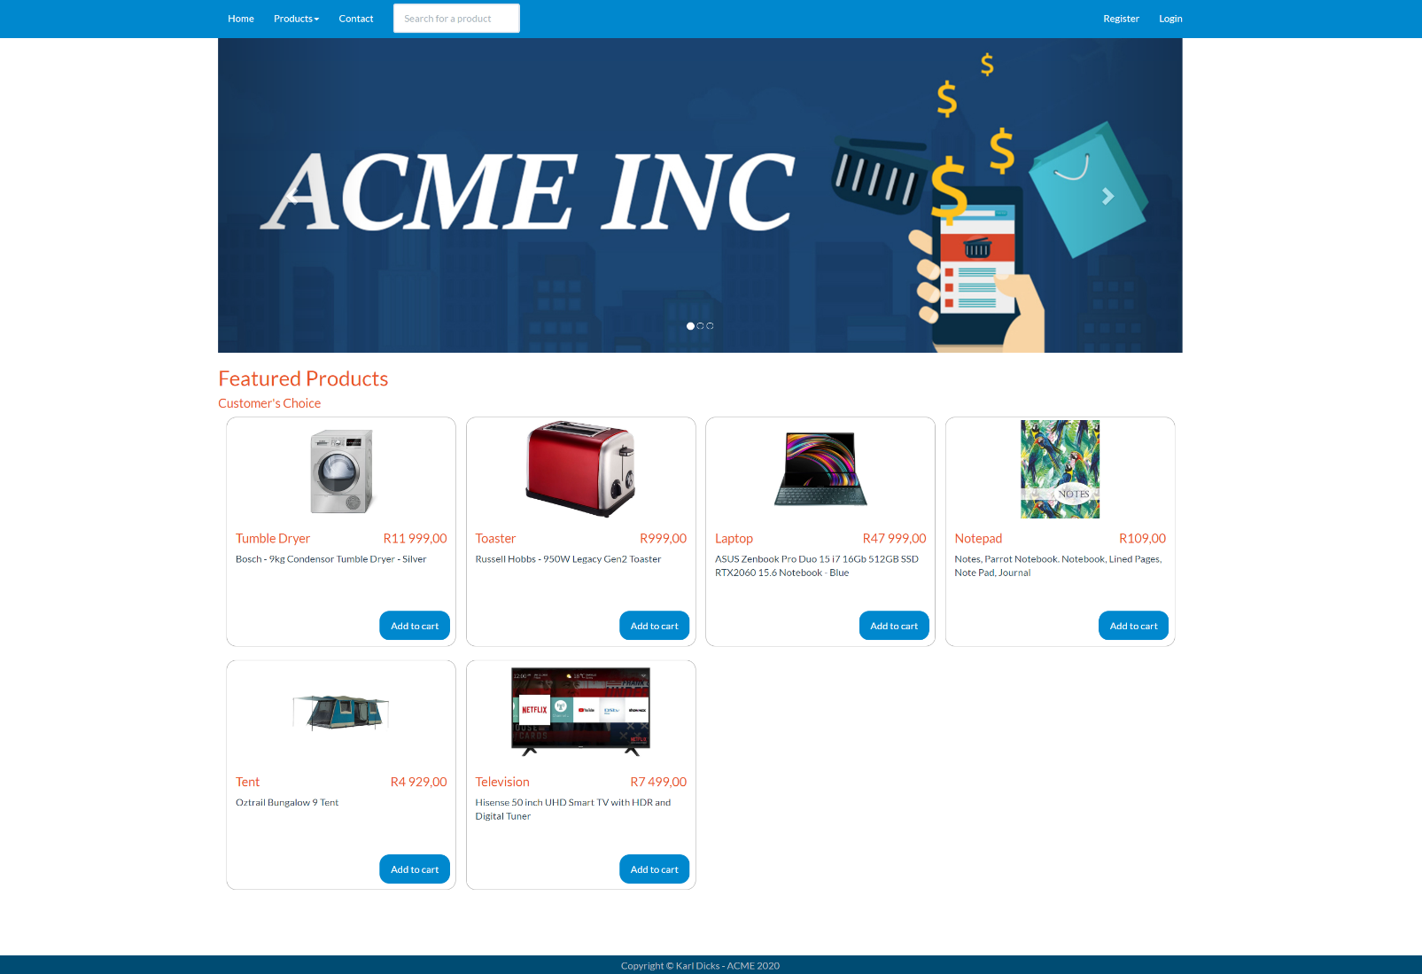**Home Page**The home page is shown by default when the user navigates to the website, and shows featured products that have been recently purchased or promoted by ACME Inc.

From this page, the user can navigate to other pages using the top navigational bar (nav bar), log into their account, register an account, search product listings, or view featured products for sale.

**Product Categories**

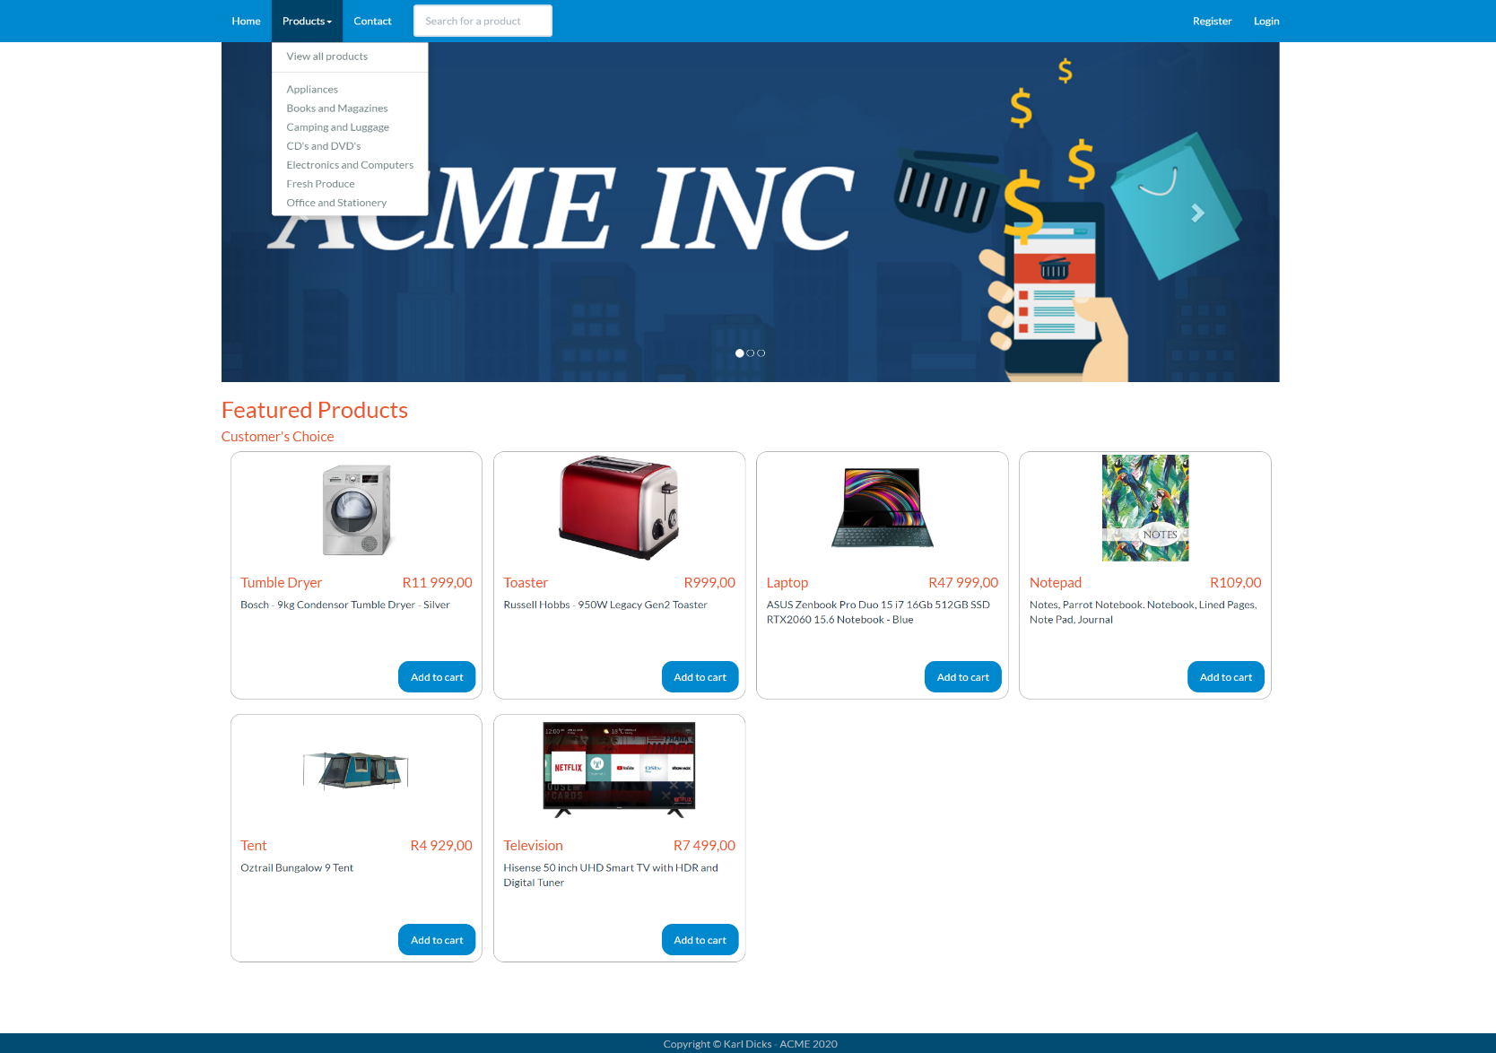When the user selects the “Products” tab on the navigational bar, a list of product categories expands, which shows all available categories of products stored in the database.

The user can select a category (which is shown on the following page), or select “View all Products”, which will show all available products on the web store.

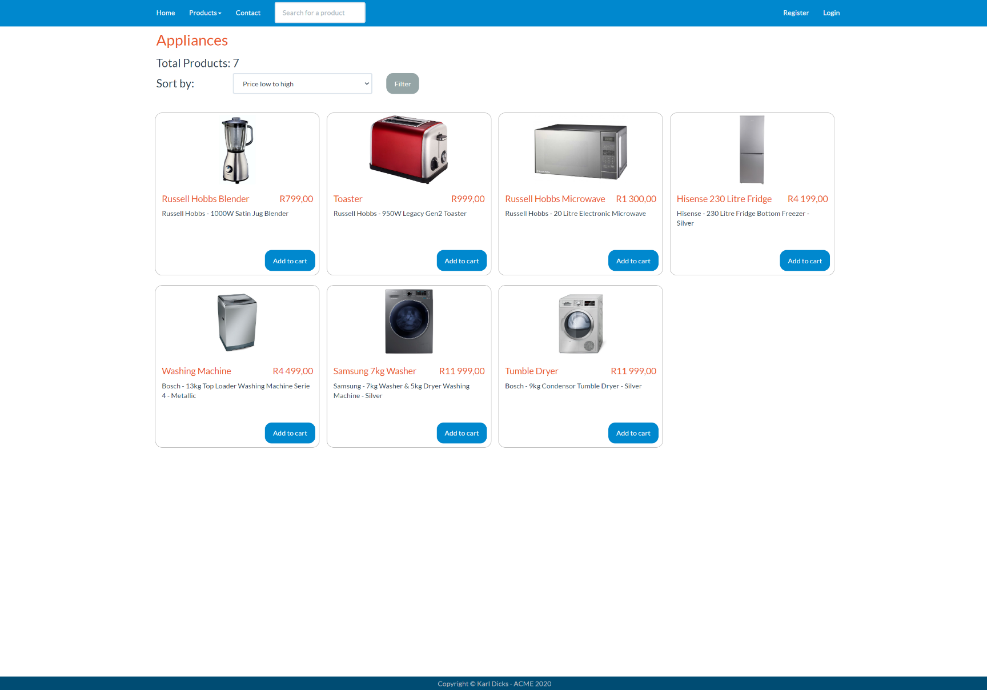**Product Categories - Example**

When the user selects a product category, they are brought to a page with all products from that category.

For example, if they select “Appliances” they will be presented with the shown page. If there are more than 12 products on the page, then a new page will be created, and the user can navigate to different pages (shown on the following page).

**Pagination**

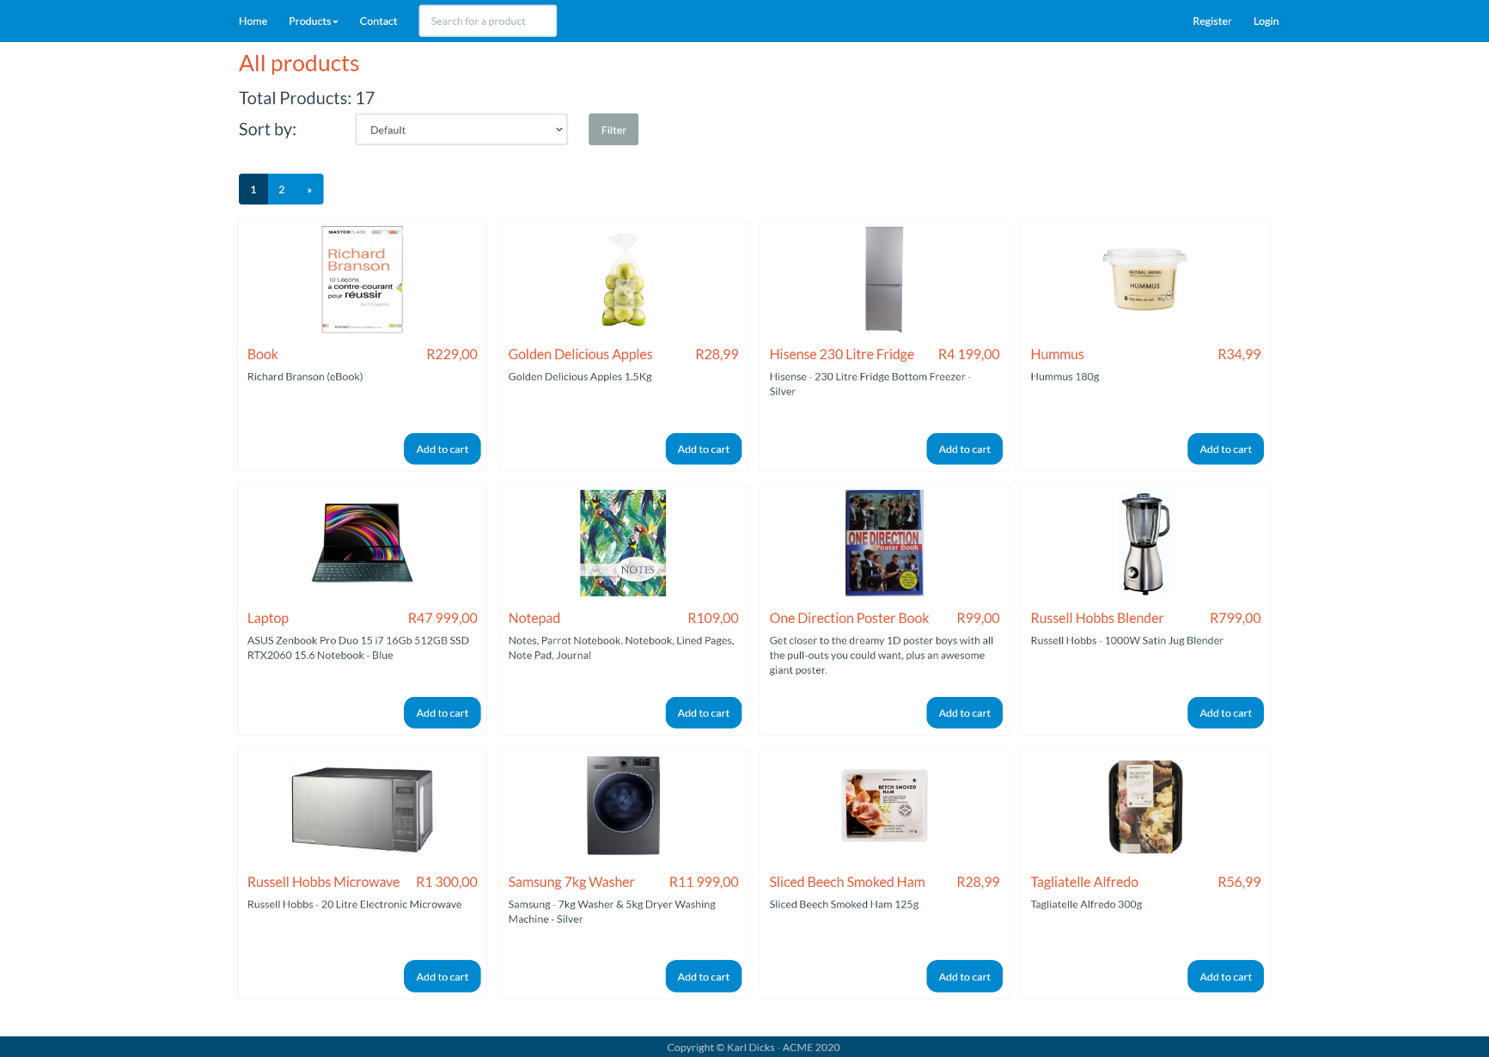As can be seen on the provided image, pagination will appear once there are more than 12 products on the page.

The user can navigate to additional product by selecting the page from the pagination selector, or skip to the end (or beginning), by clicking the “>>” or “<<” next to the page numbers.

In addition to this, users can filter by price (low to high, or high to low).

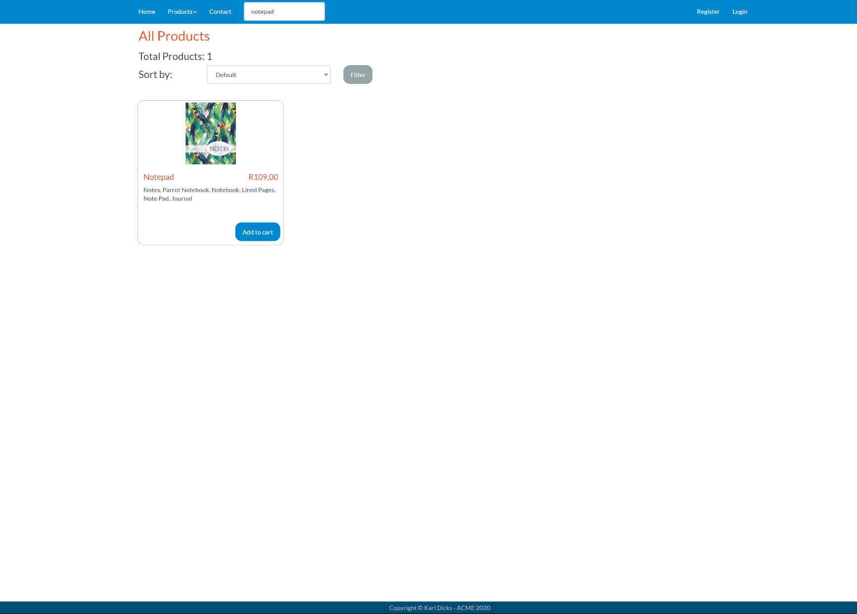**Product Search**

The user can enter a search string in the “Search for a product” text field in the navigation bar at the top of the website, and view all results for that search phrase in a new page.

An example is shown in the provided image.

**User Registration**

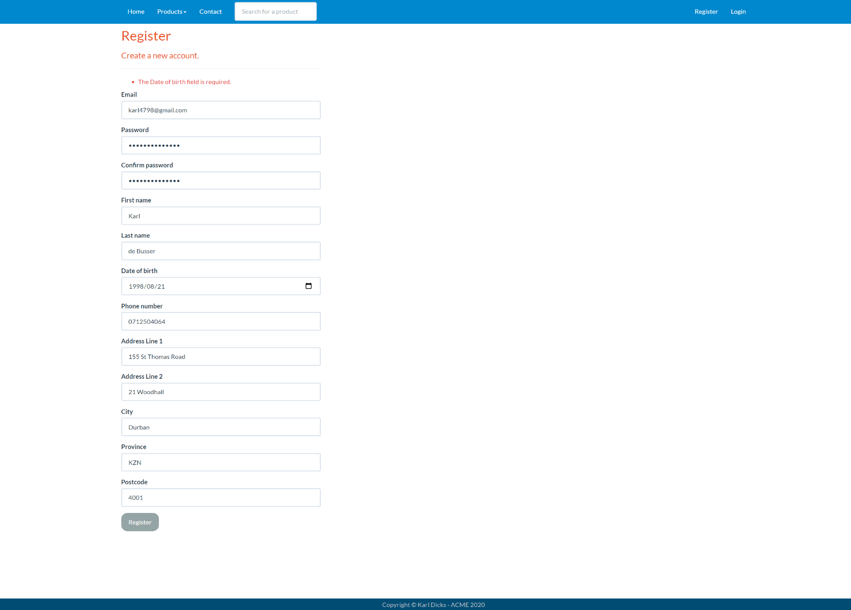The user can register a new account when they navigate to the “Register” page, fill out the form, submit the form, and then verify their email (using the link sent to their email address).

*Please note the email must be opened on the test system, as it will route the user to the localhost IIS server*

Details include your name, address, date of birth, phone number, and account information (email and password).

**Email Validation**

Once the user successfully fills in the registration form and submits it, they can check their email (on the test system) and validate their email, before they can log in.

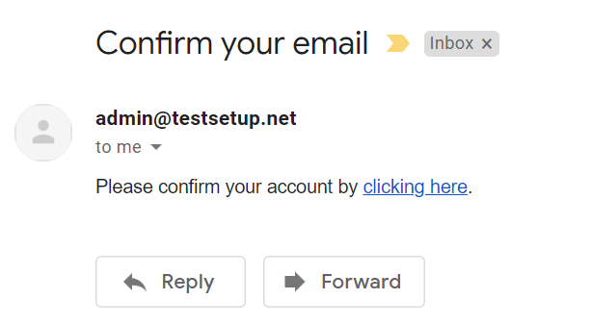**Email Verification Link**

After the registration process has been completed, the user can check their email for a verification link. Once they receive the email, they can use the provided link to verify their account. This uses an online hosted email account (Afrihost).

Once the user verifies their account by following the link provided in the email, they can log into their account on the web application (shown on the following page).

Once the user has clicked the verification link, they will be brought back to the ACME web application, and their email will be verified.

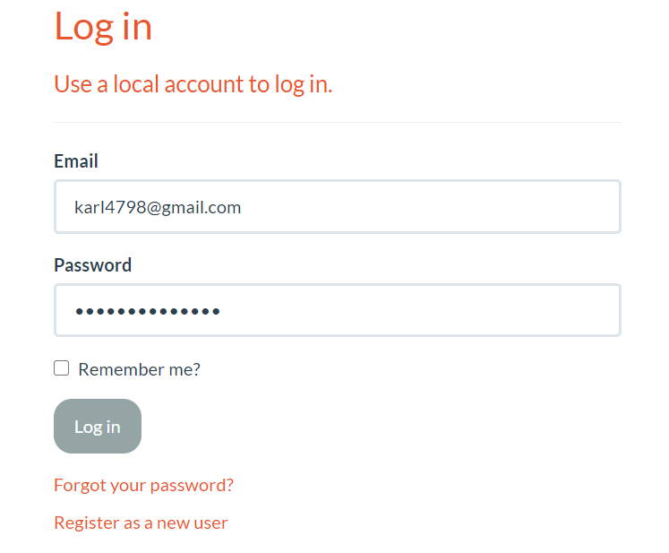**User Login**

Once the user navigates to the “Login” navigational bar tab, they are presented with a login page, where they can enter their unique credentials and log in as either a customer or administrator.

Role Based Access Control (RBAC) has been implemented, so that customers can only access certain parts of the web application, and administrators can add, update, view, and delete products, etc but not checkout.

An example of a customer logging in is provided in the image.

**Cart**

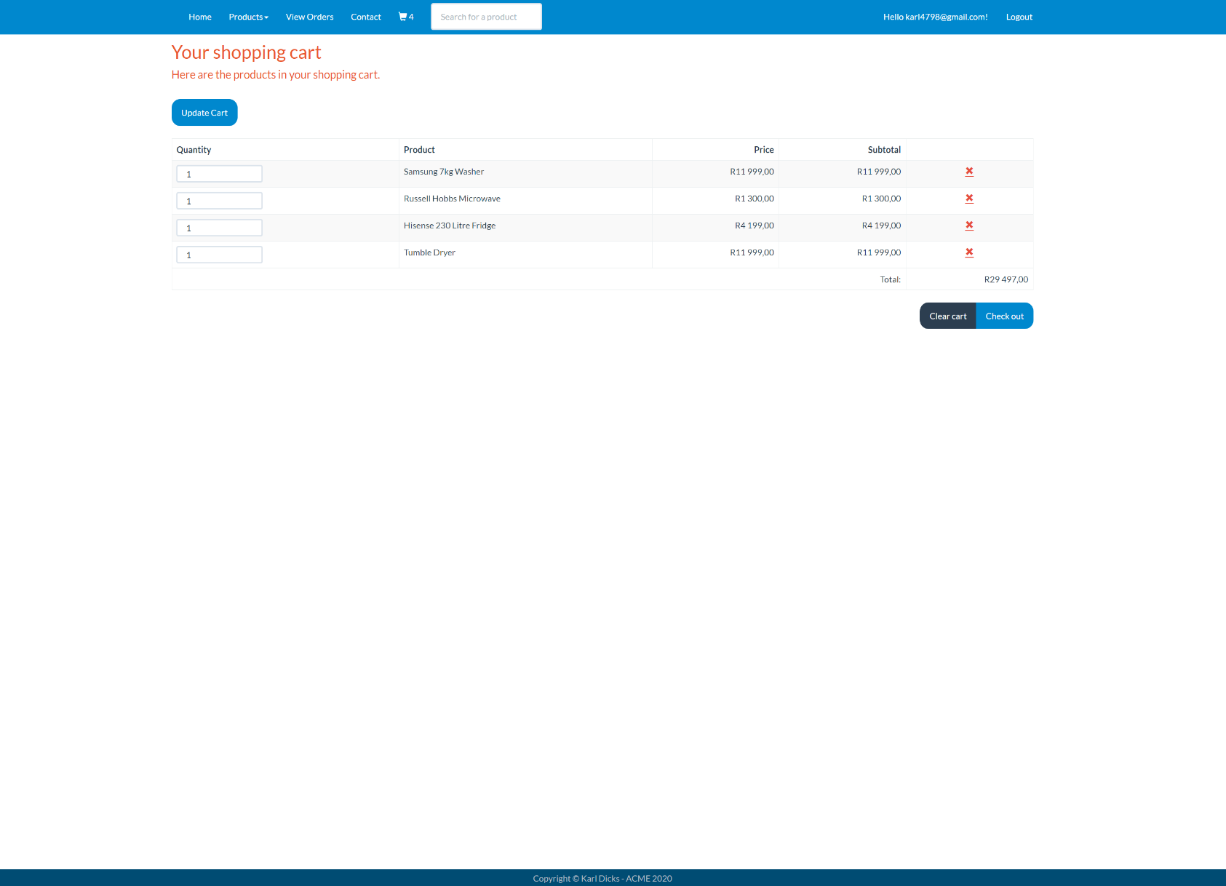Once the user has logged in, they can add items to their cart, update their cart, and check out.

An example of a cart has been provided in the image.

The user can remove items, which will decrement their quantity. They can increase their quantity by changing the quantity value and clicking the “Update Cart” button.

The user may clear the cart using the dark blue button “Clear Cart”.

Once the user has added all required items to the cart, they can press the “Check Out” button to check out (shown on the following page).

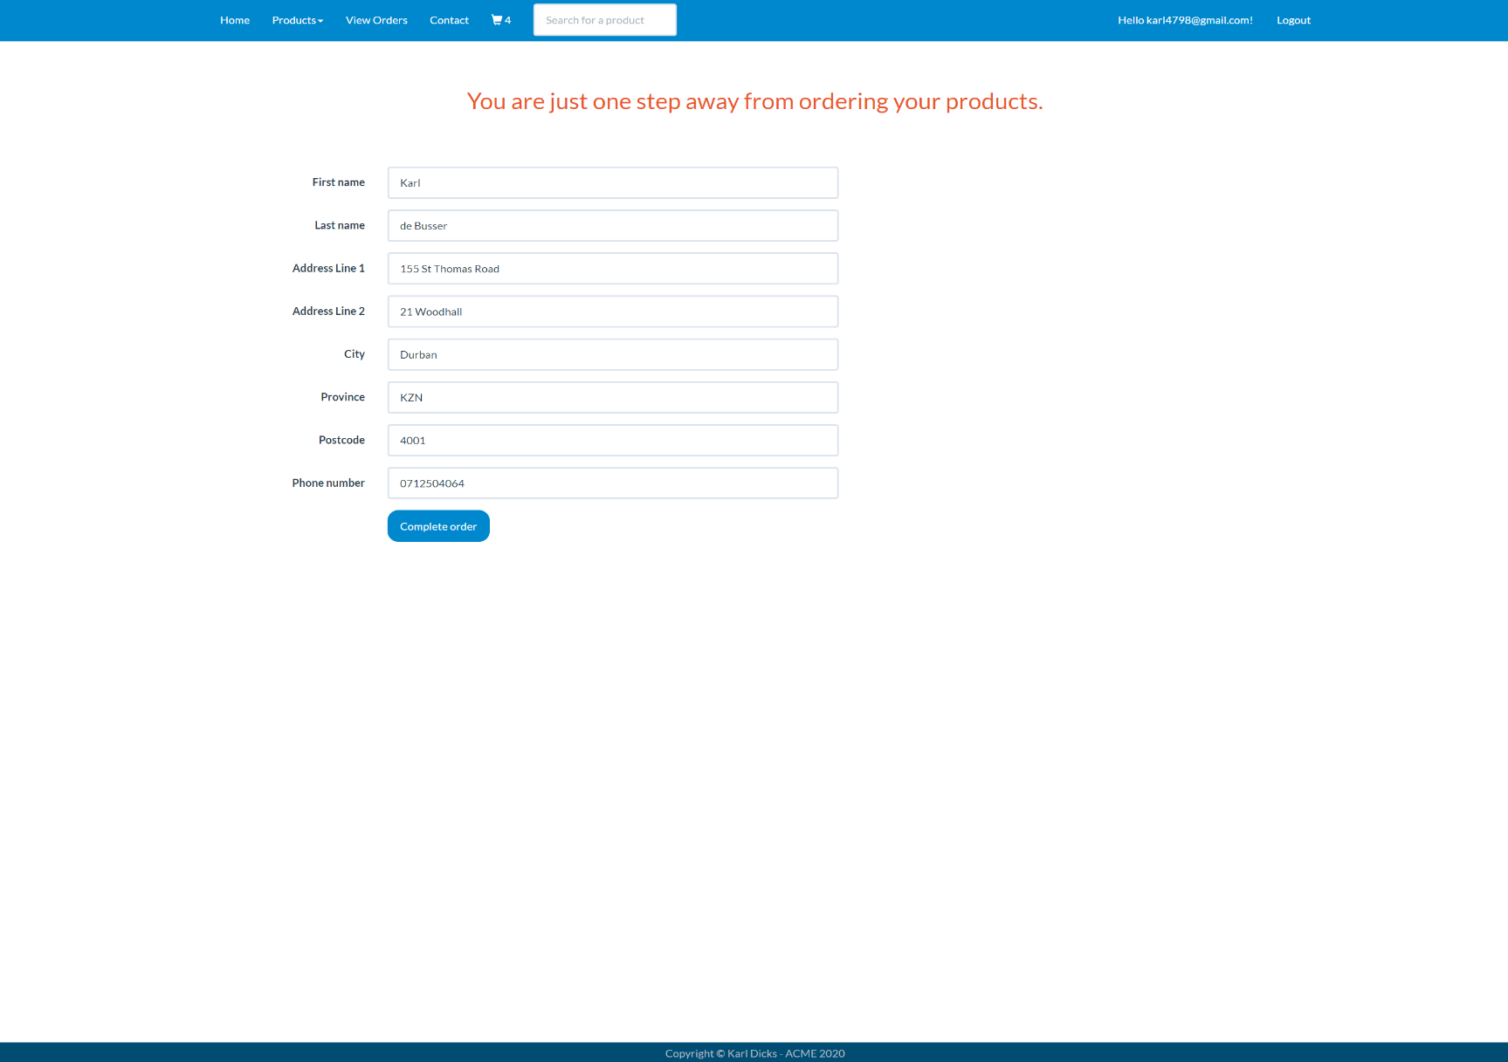**Checkout**

Once the customer has added all required items to their cart, they can check out.

The checkout details will be pre-populated from their account, however they may change them.

For example, the user can send items to a different address, by editing their details on the checkout page. This will not save to their account, however the order will be completed with the provided information.

Once the “Complete order” button has been pressed, the order will be confirmed and logged by the system.

**Complete Order**

Once the user has clicked the “Complete order” button, they can view all previous orders by navigating to the “View Orders” navigational bar button on the header.

**Orders - List**

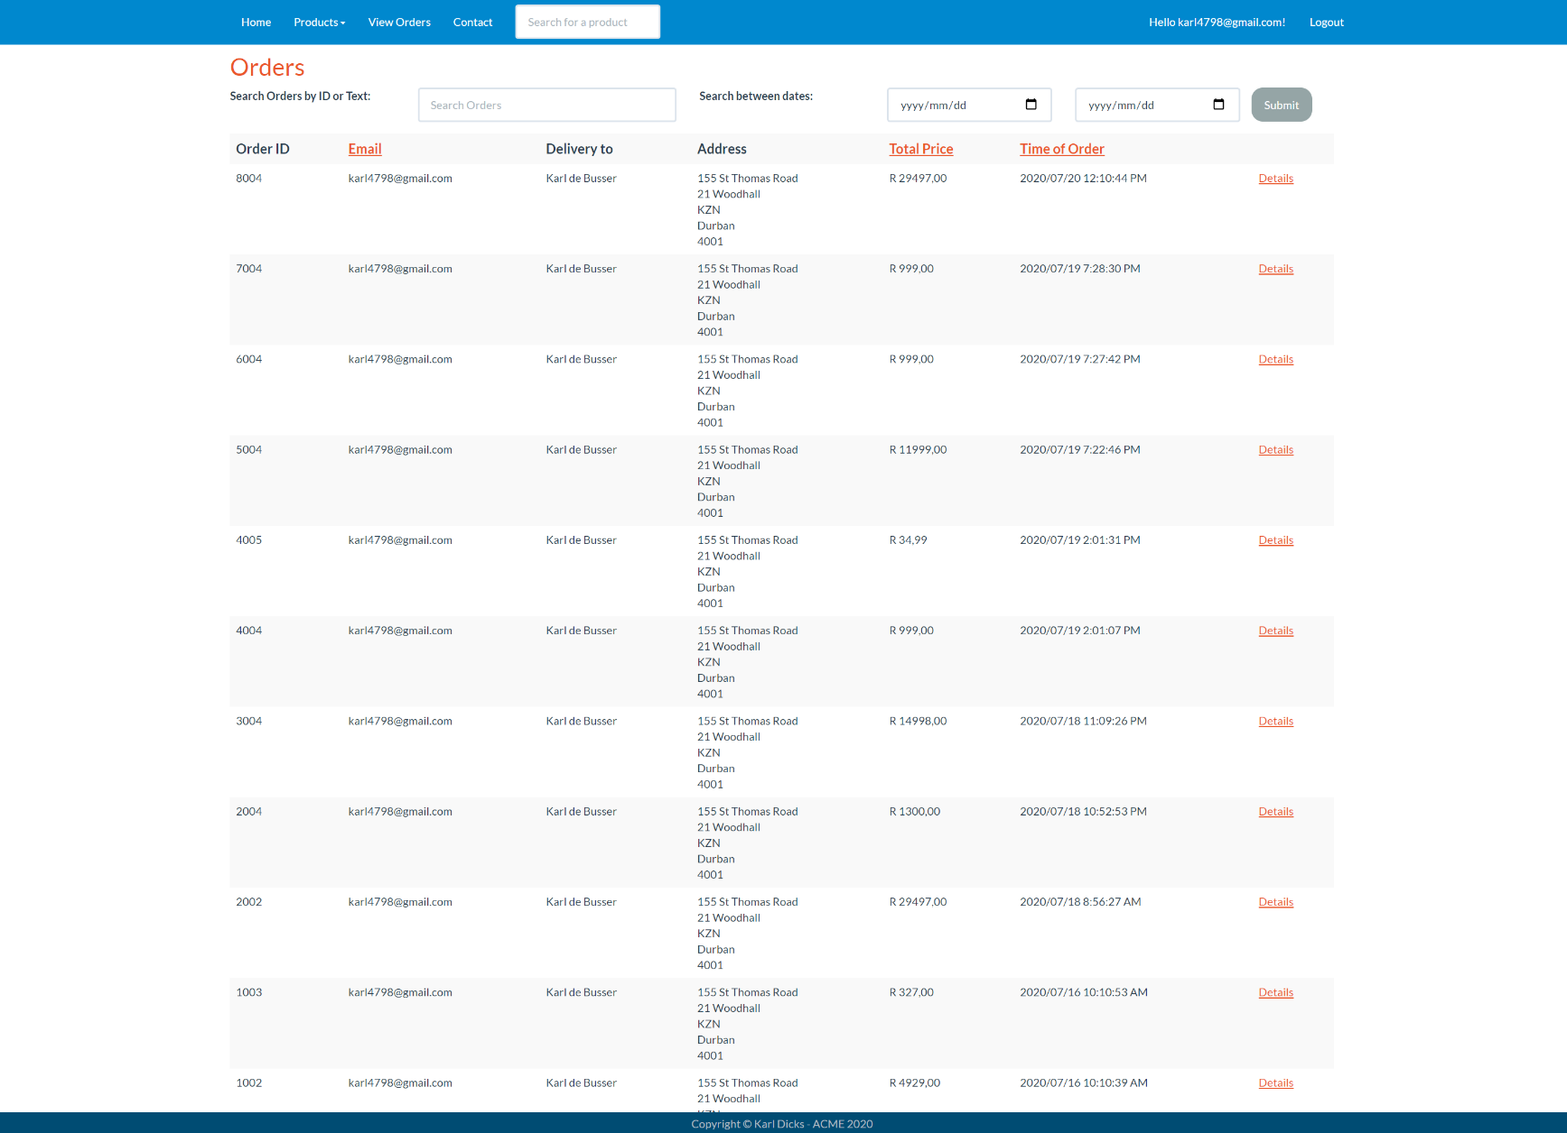If the user navigates to “View Orders” tab on the navigational bar, they can view all previous transactions.

For example, you can see the latest order with a time stamp of “2020/07/20” was the order placed in the previous pages.

The user can search orders by ID or Text, and also by date.

**Orders – Details**

Once the user selects the “Details” link on any order item, they can view the order details (itemized billing).

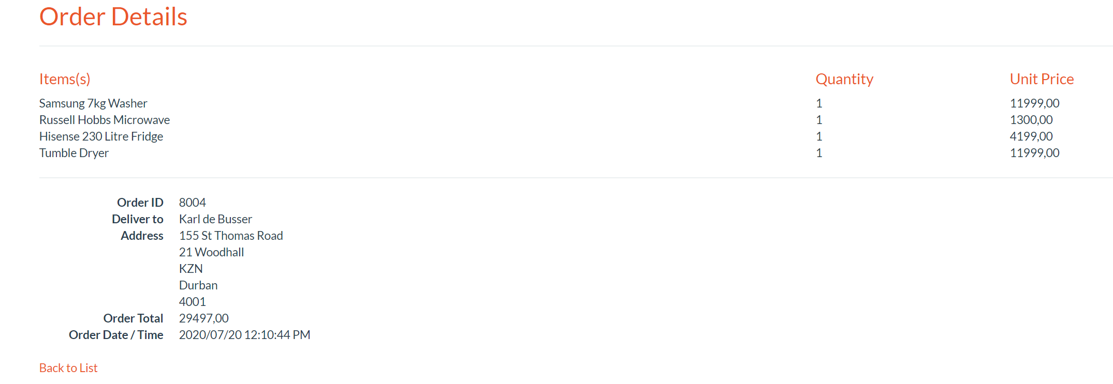This details page provides the item name(s), quantity, unit price(s), total price of the order, and delivery address and name.

Users can sort by email, total price, or time of order.

**Contact us**

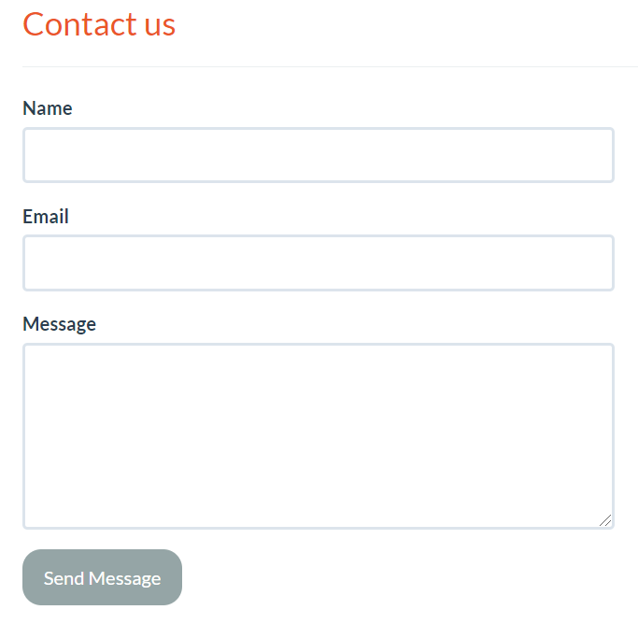The user can contact the ACME staff through the contact form on the website, which will send an email to a hosted email account at Afrihost ([admin@testsetup.net](mailto:admin@testsetup.net)). This email can easily be changed when the website is published.

The user may enter their name, email, and message content. Once they have filled in these details, they can click the “Send Message” button to submit their message.

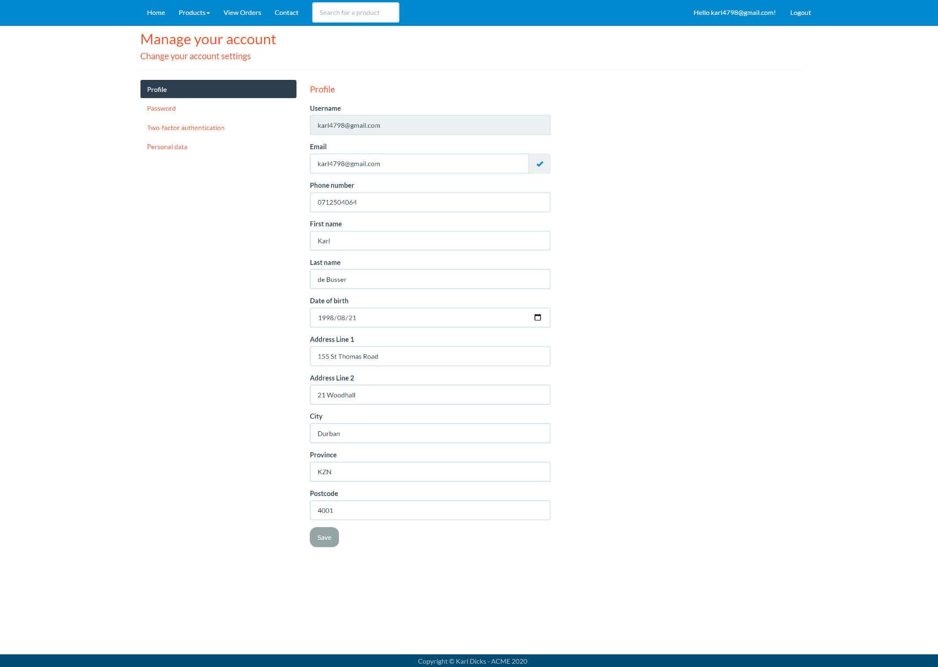**Account Details**

Customers and administrators can edit their personal and account information when they click their email address on the navigation bar.

In addition to this, the user may reset their password, change their email, set two factor authentication (using Google Authenticator App), or download or delete their personal information.

**Administrator View**

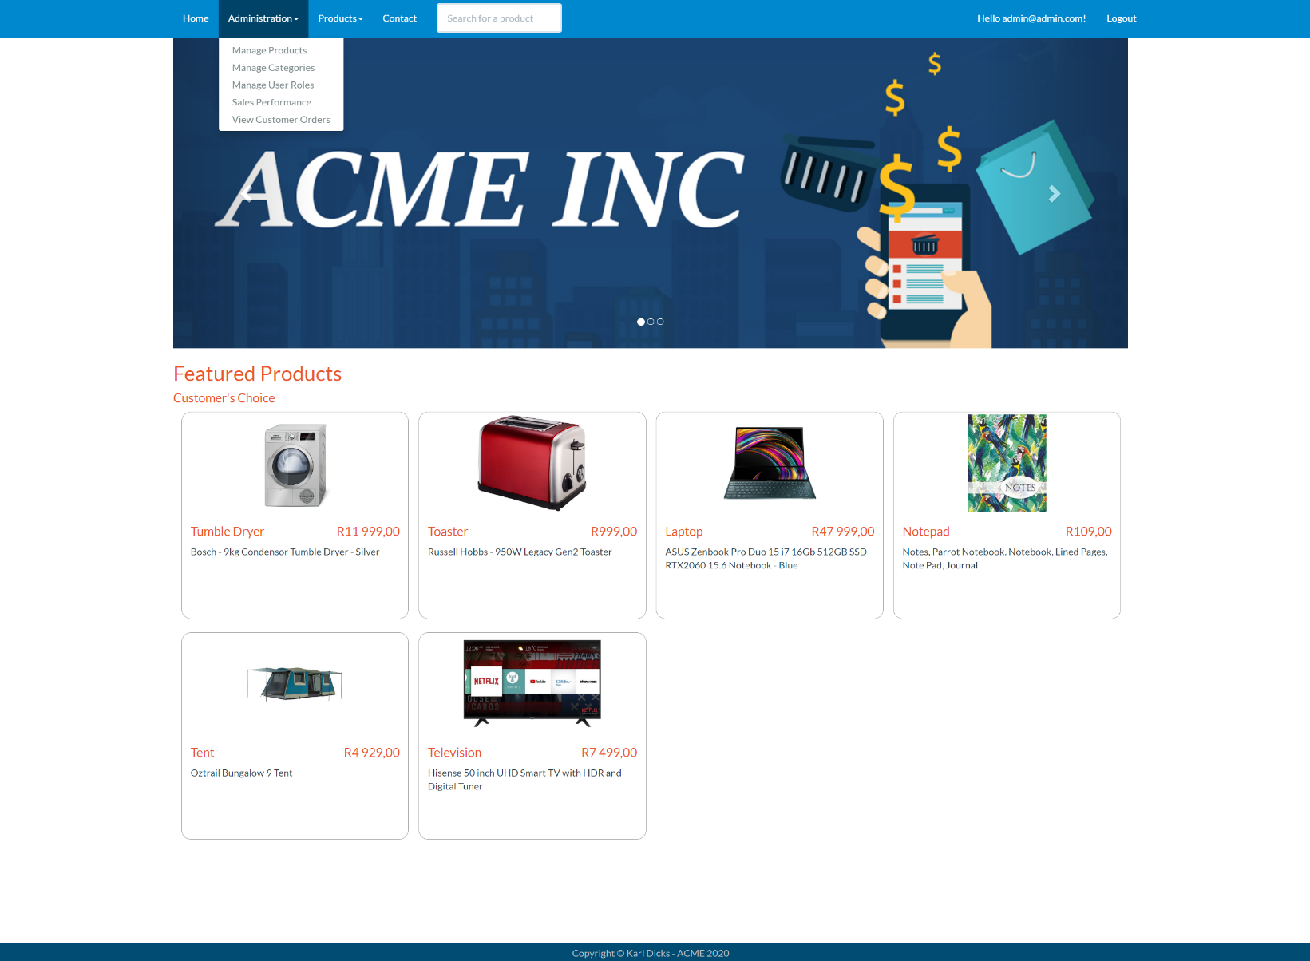Once an administrator logs into the application, they may view an “Administration” tab on the navigation bar at the top of the website.

This dropdown contains links to manage products, categories, user roles, view sales performance, and customer orders.

The administrators also do not have access to purchase items from the store using their admin account.

Administrators can elevate users (customers) to admin role from within the “Manage User Roles” tab. An administrator account has already been created for testing purposes:

Email: [admin@admin.com](mailto:admin@admin.com)  
Password: P@ssword123!

**Administrator View - Products**

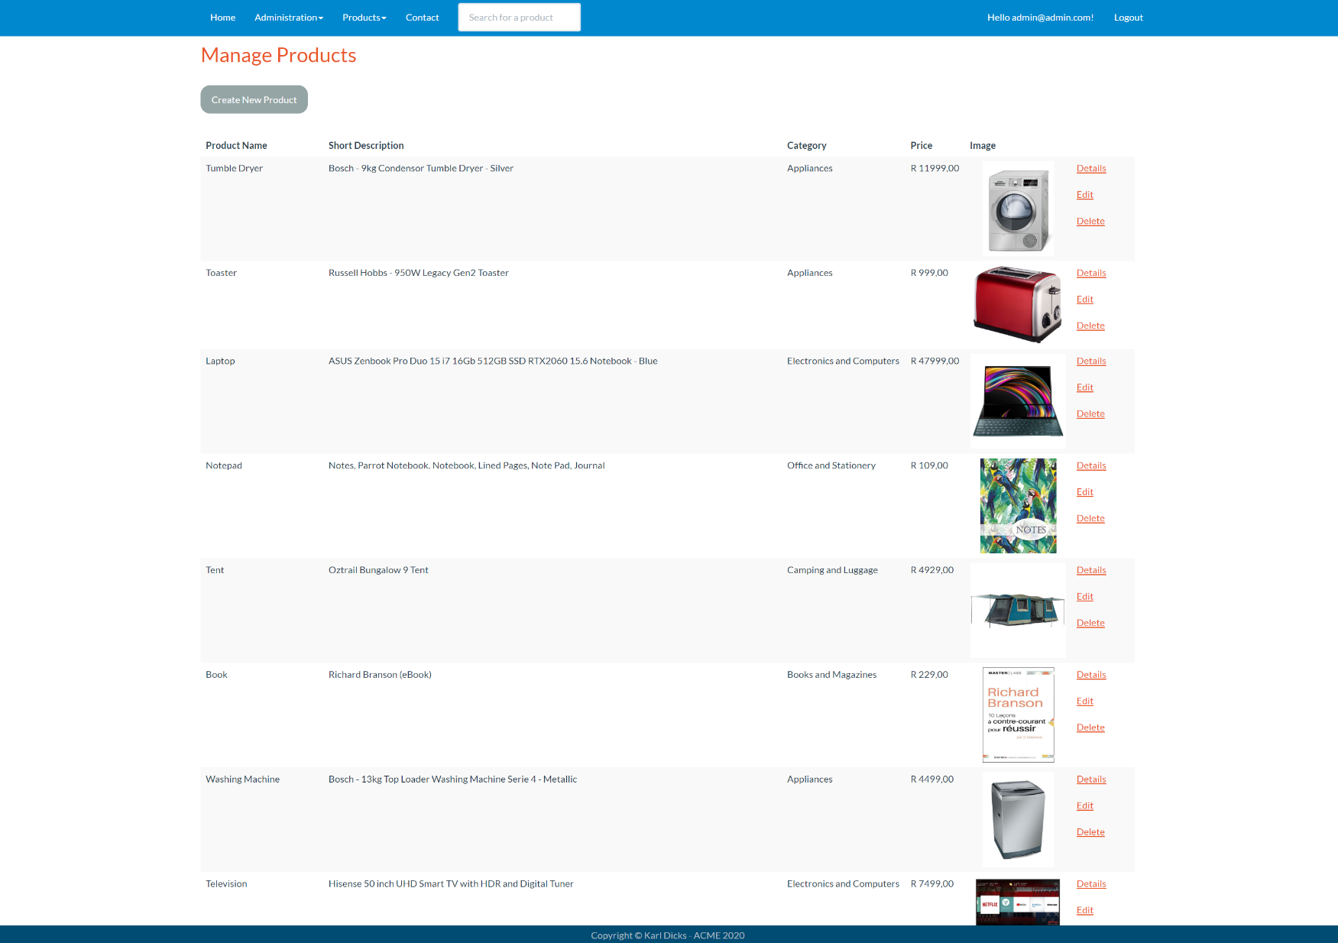The first tab made available to the administrators of ACME web application is the “Manage Products” page, where new products can be created, and will be viewable by customers, and purchasable if they are in stock.

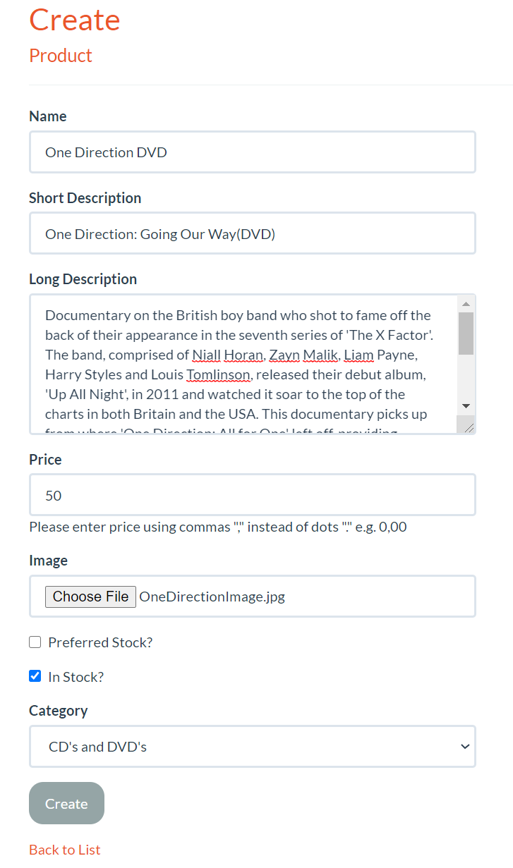**Create Product**

Administrators can create new products by clicking the “Create New Product” on the “Manage Products” page. This will allow them to enter product details, and upload an image for the product.

If the product is “Preferred Stock” then it will appear on the home page of the website, under the banner images (carousel).

Only if the product is in stock will customers be able to purchase the item, otherwise they will not be able to add the product to their cart and checkout.

**View Product Details (Administrator)**

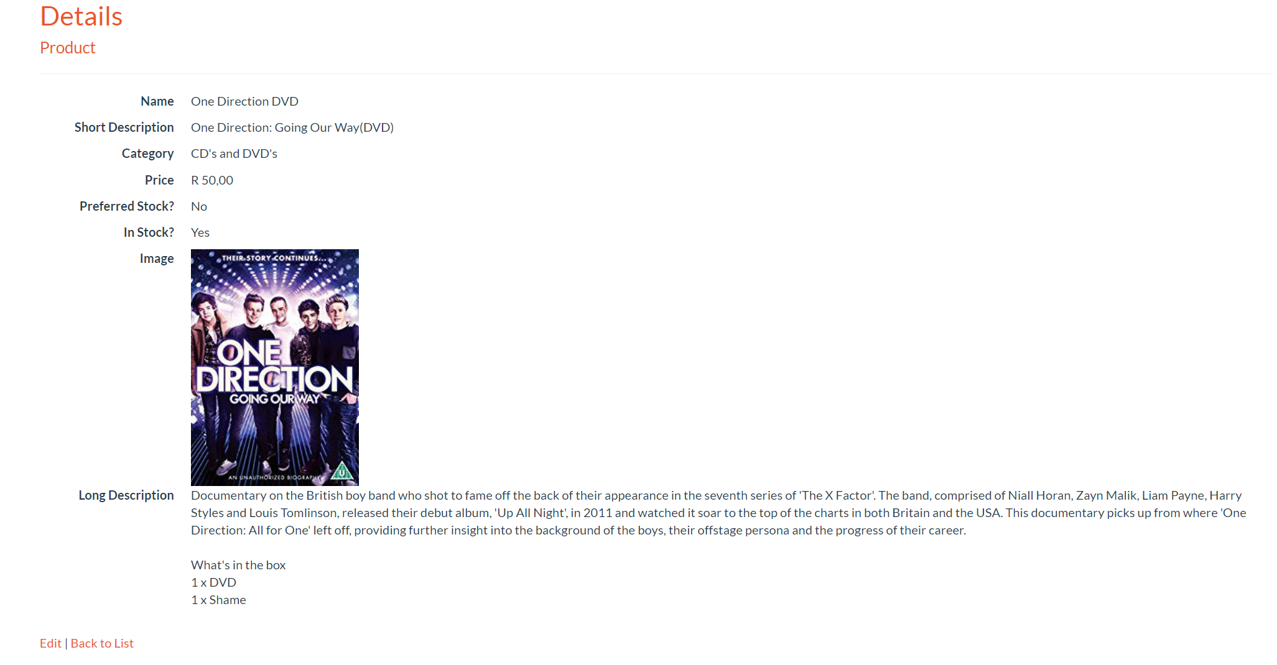Once the product has been created, the administrator can access product details by clicking the “Details” link next to the item listing.

This page shows product details, such as name, description, category, price, image, and other such information.

**Edit and Delete Products (Administrator)**

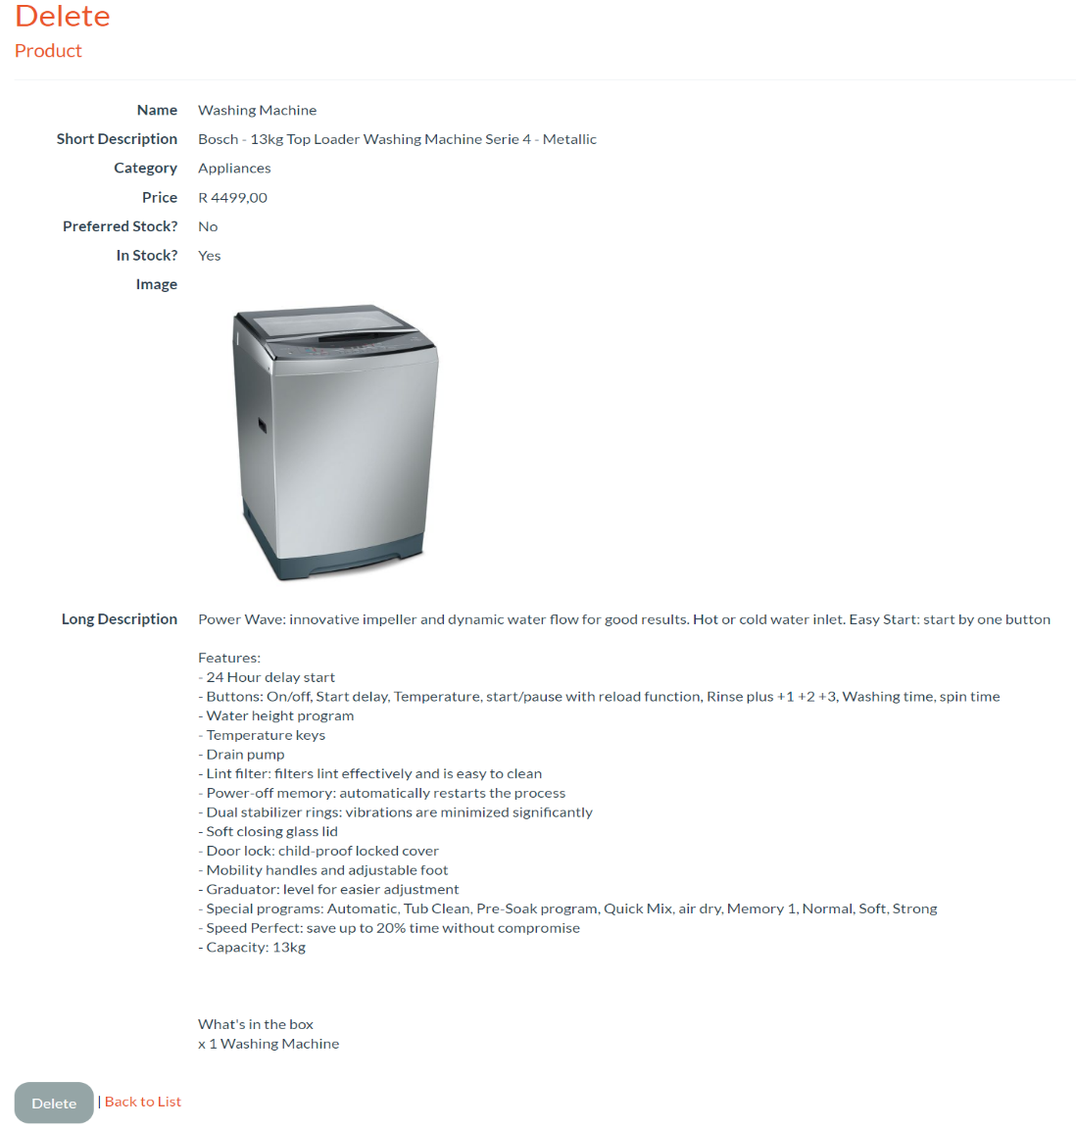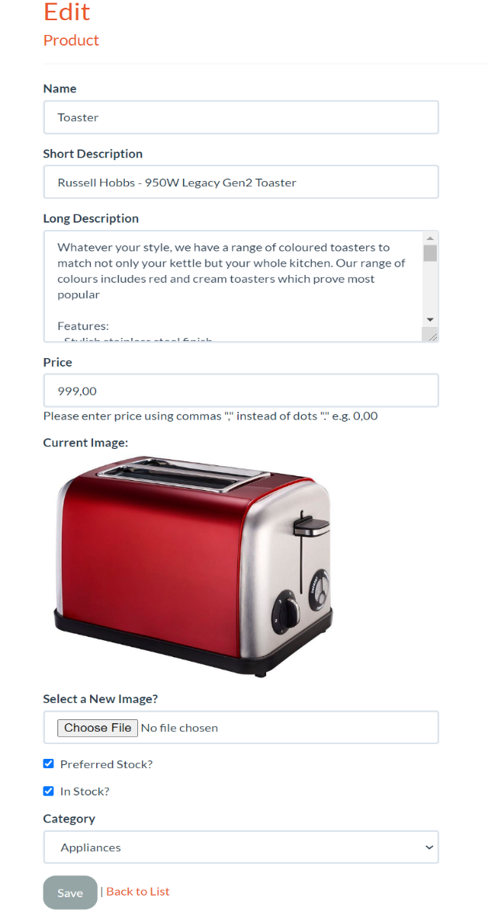

The administrators can create, view, edit, and delete products from the “Manage Products” views.

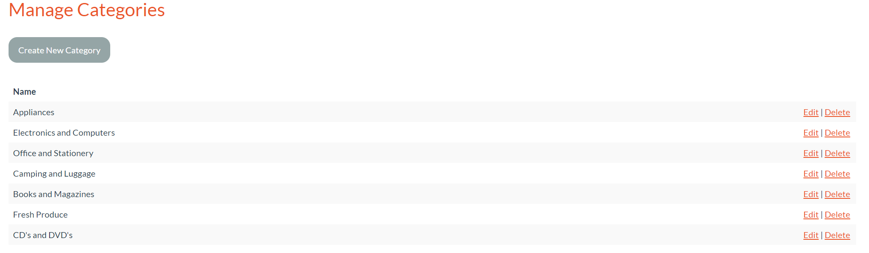**Manage Product Categories**

Administrators can create, view, edit, and delete categories, which can be used to categorize products, as products can be assigned to a category. For example, Appliances will have Washing Machines, Fridges, etc.

Each product must be assigned to a category, and can only be assigned to one category.

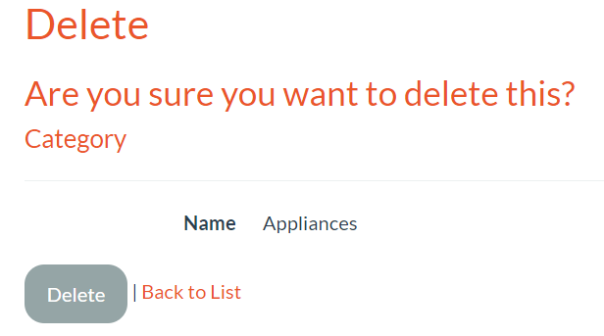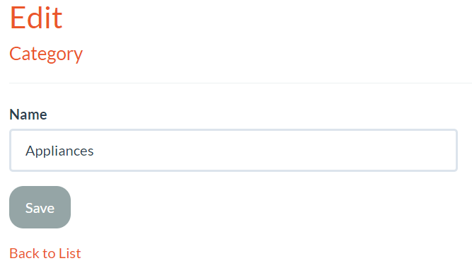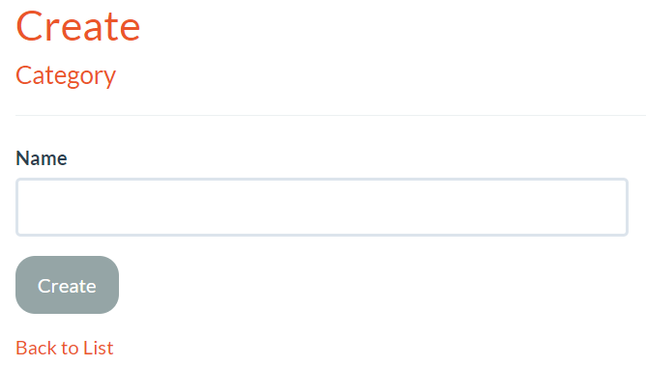**Categories Views**

Product categories can be managed from the “Manage Categories” views, which allows administrators to create, view, edit, and delete categories.

When editing categories, the new category name will be used for all products currently assigned to that category. If a category is currently in use by a product, then the category cannot be deleted, and an error message will be displayed.

New categories will be displayed in the “Products” dropdown list on the website for both administrators and customers, so that navigation to these new category pages are made available.

**Manage User Roles**

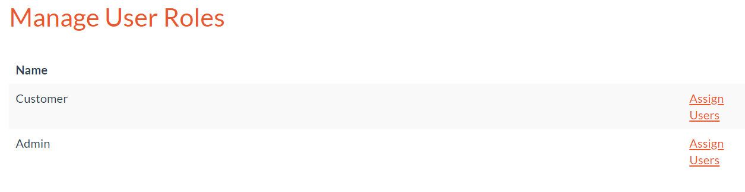

The administrator can assign users to two roles – “Customer” and “Admin”. These roles grant access to different web application functionality.

For example, a customer will not have access to the “Administration” tab, and therefore cannot elevate their account to administrator, edit products, delete products, and much more.

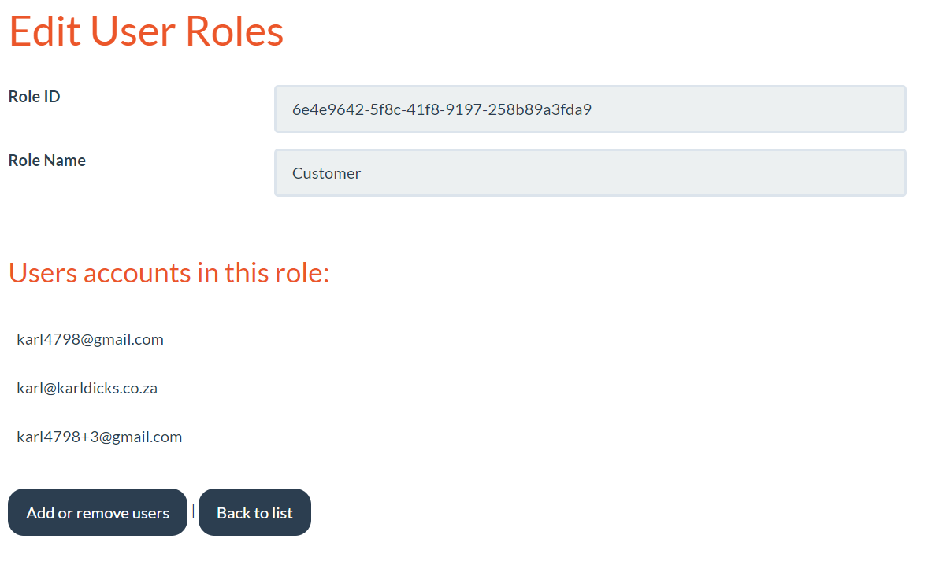Administrators can however elevate users (customers) to have administrator access. This will grant them the same permissions as an administrator. This has been incorporated so that multiple admins can manage the site.

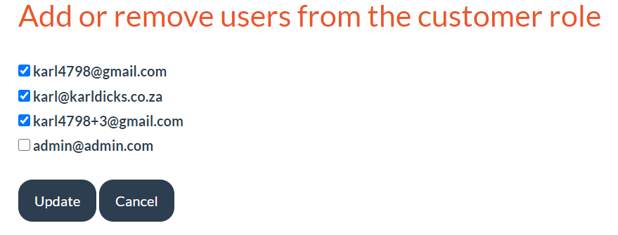**Add or Remove Users from a Role**

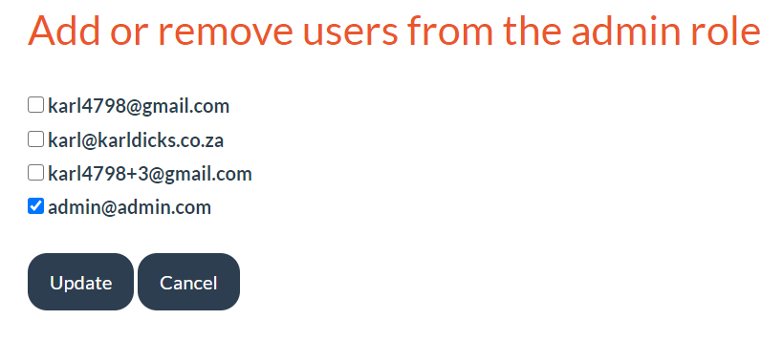As can be seen in the provided images, certain users are assigned to the customer role, however only [admin@admin.com](mailto:admin@admin.com) is assigned to the admin role.

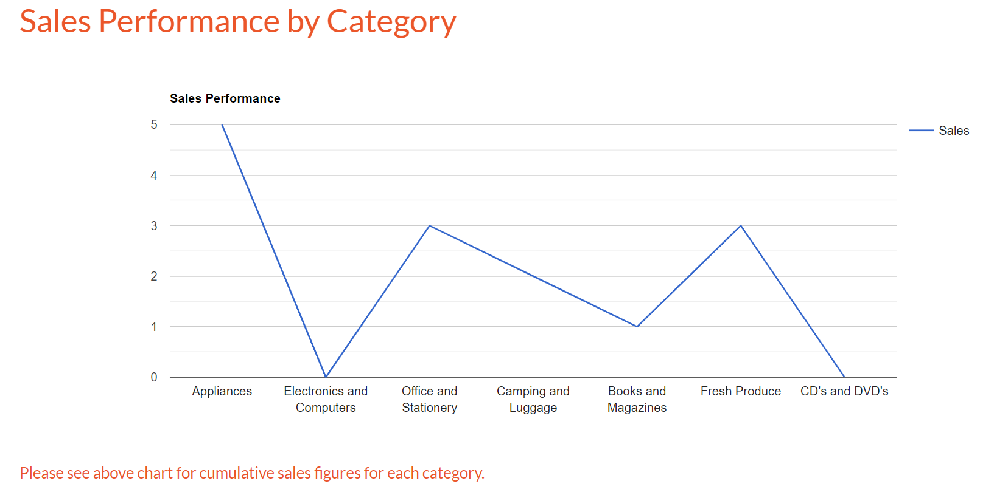**Sales Performance by Category**

Administrators of the web application can view sales performance over time by category.

For example, there are 7 categories now, however categories can be added, and if the user hovers over a category (at the intersection with the line chart), they can view cumulative sales figures for that specific category.

**View Orders (Administrator)**

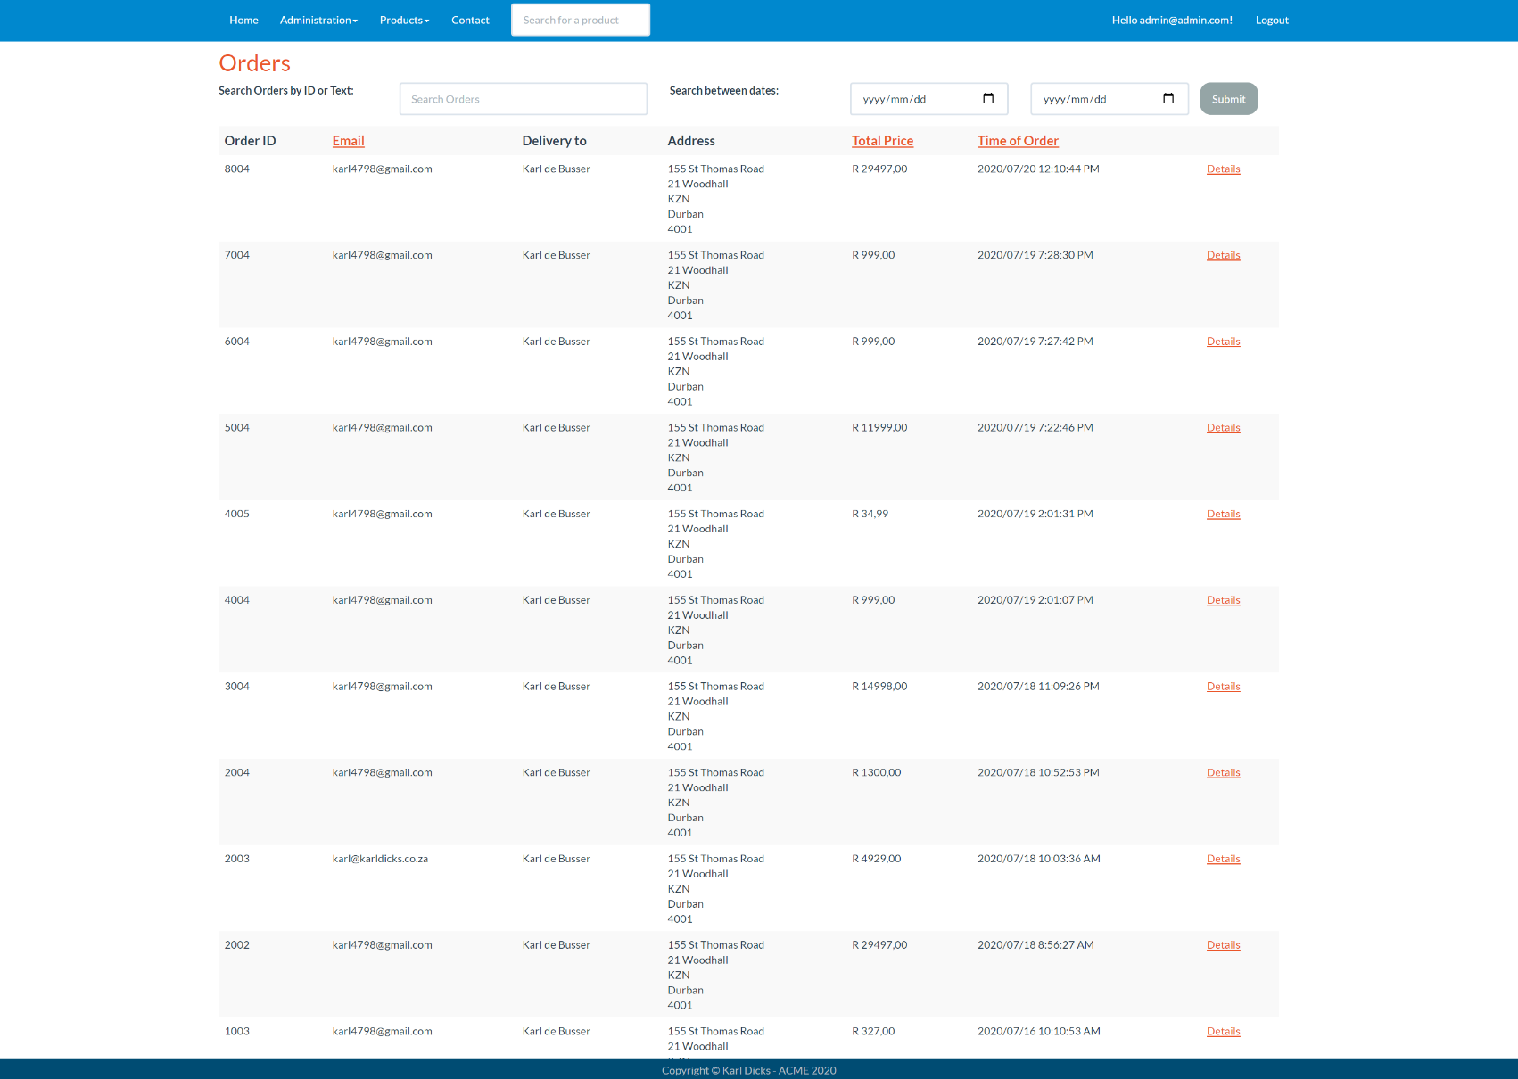The administrator can view all orders made by all customers, and therefore can ensure that they are fulfilled.

All orders are searchable, and by default are ordered by date added – therefore the latest orders will be shown first.

The administrator has the contact details, address, and items purchased when they click on the “Details” button.

# **Database Entities**

ACME will use Entity Framework (Microsoft SQL) Code First to develop the database. It therefore contains multiple model and view model classes, which have been provided below.

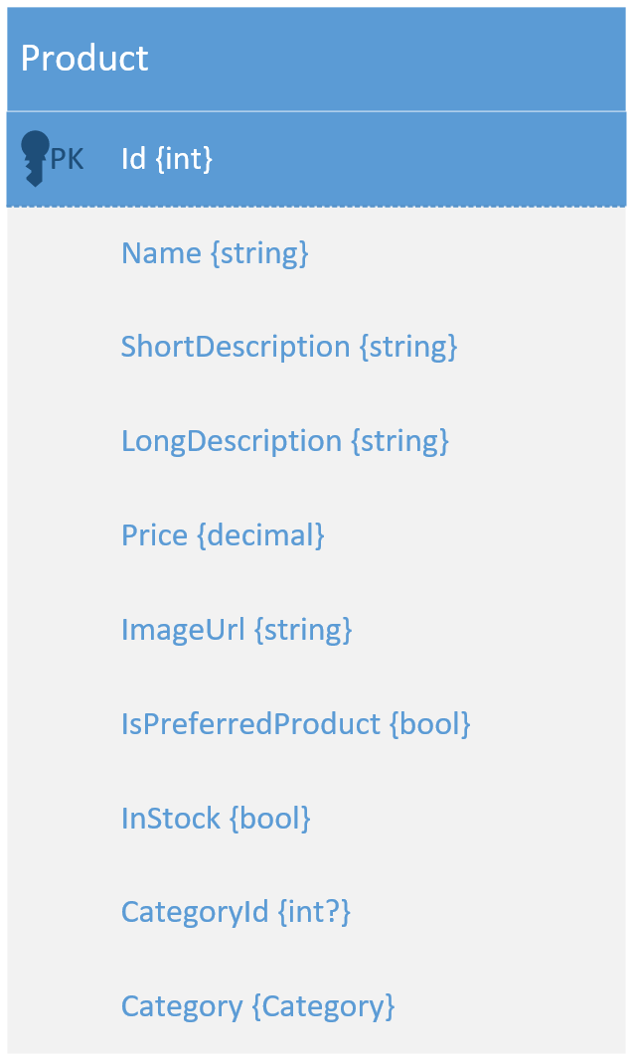The product entity has been created to store product attributes, such as product name, descriptions, price, image URL, stock status, and more.

The product is assigned a category ID, and through this model its category name can be found.

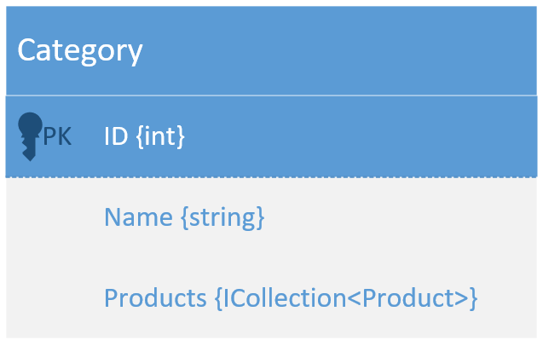Product categories are stored in an entity called “Category”, which stores the category name, ID, and a list of all products linked to the Category.

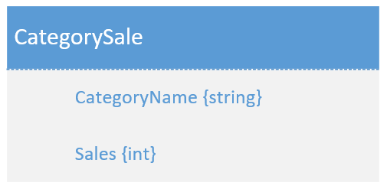

CategorySale entity has been created to store the number of sales per category. The “Sales {int}” is incremented every time a new sale is made for that category (including the quantity of products sold for that category). This allows admins to view sales performance for particular categories over time.

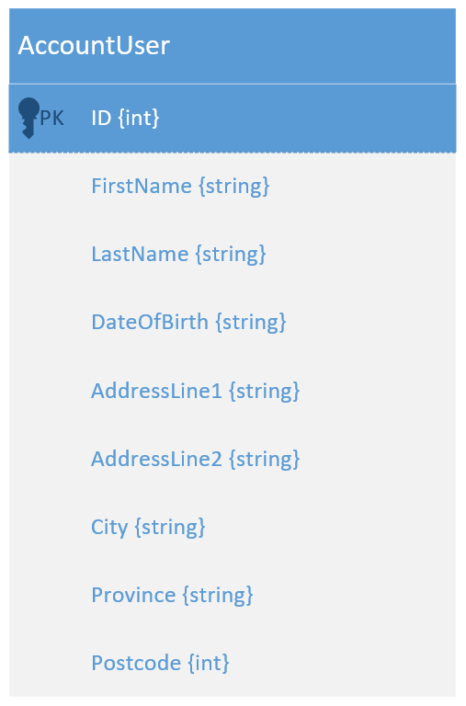AccountUser entity extends the IdentityUser model automatically brought in for saving user information, so that the application can store additional fields.

These fields include the first and last name of the user, date of birth, and address, in addition to the IdentityUser fields which include phone number, email, and password.

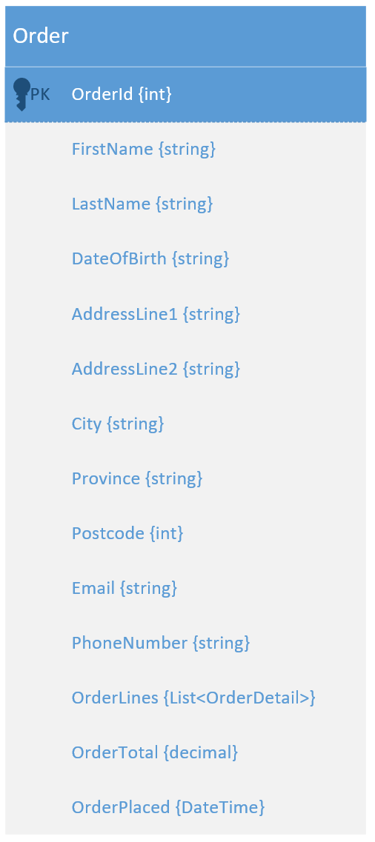The Order model was used to define what an order looks like – it includes the personal information of the buyer, such as their name, address, email, and other contact methods, along with the time that the order was created, total price of the order, and a list of order lines (details).

The order details is shown on the following page, which contains all the details of the particular order (itemized billing).

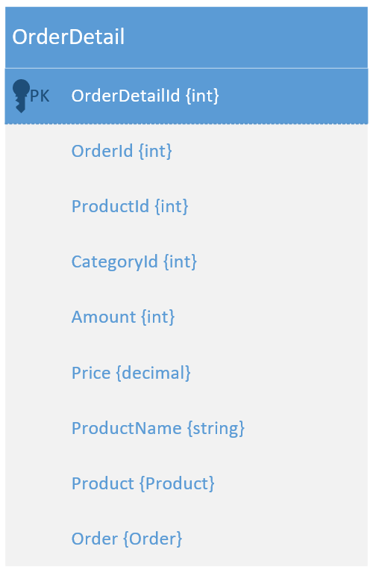The order detail model defines what is saved for each order. This includes the order id, product id, category id, amount (quantity), price, product name, product object, and order object.

For each order there may be many order “lines”, for each product added to the cart and included in the order.

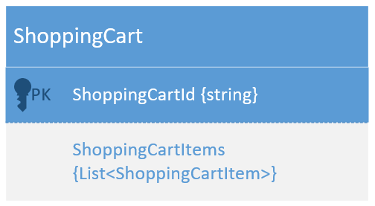

The shopping cart model defines how a shopping cart object is structured. A shopping cart has an id, and all shopping cart items in a list (shown below).

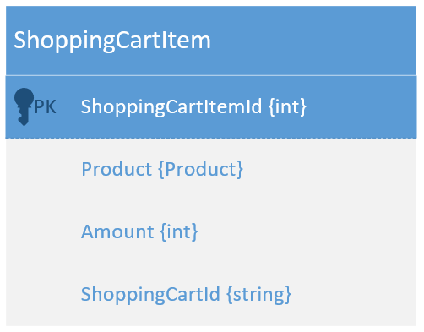A shopping cart item defines how a shopping cart item will be stored. A shopping cart item will have an id, product object, amount (quantity), and shopping cart id (constraining it as a foreign key with the shopping cart entity).

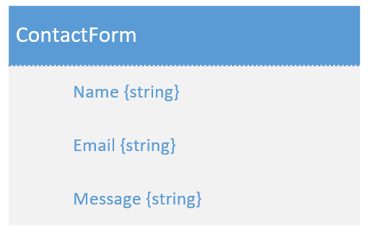The contact form entity defines how a contact form message will be structured. It will contain the sender name, email, and message content.

**Some considerations have been taken during the implementation of the database, including:**

* All information stored in the database (MS SQL MDF file) will only be accessible by authorised users.  
  Each user will have their own account, and will only be able to view their own information for their account, and not others – securing information.
* Email addresses which have been used to sign up must be unique, otherwise the web application will throw an exception, which will be caught in an error message. This error message will inform the user that there is already an account created with the provided email address.  
  The account email address must also be verified before use.
* The user may download or delete their account within the user preferences page if they wish to do so.
* Logging out will end the user session (invalidates the cookie), which secures the application and user data, as the user cannot use the “back” buttons to restore the session – they must be re-authenticated using their unique email and password combination (and 2FA if set up).

**How is the data stored?**

ACME web application currently uses an MDF file to store user accounts, products, categories, and other such information.  
Once the application has been published it will use Microsoft Azure SQL, and Azure Blob Storage for product images.

The product images will rather be stored in Azure blob storage, and be given a globally unique identification number in order to locate these product images. The web application itself will also be published to an Azure App service, so it can be accessed online.

For demonstration purposes, the MDF file has been placed in the App_Data folder within the root directory of ACME web application.

# **Use Case Diagram**

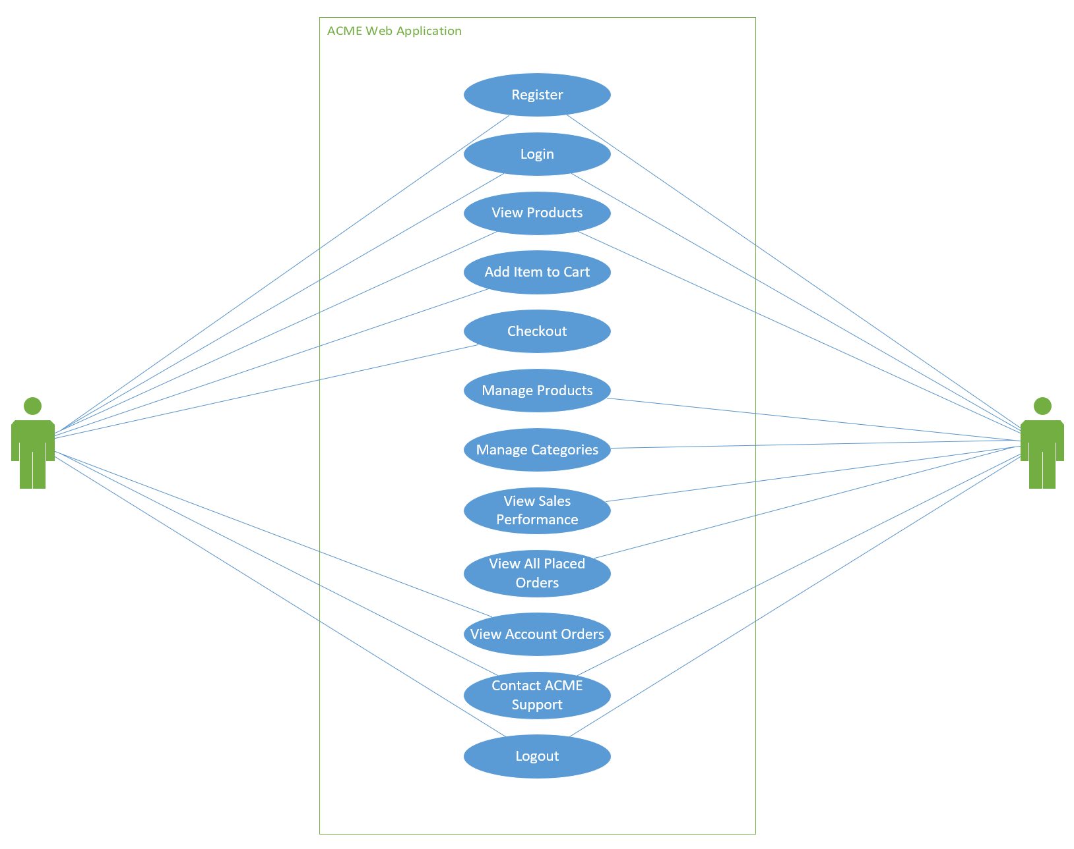

The above use case diagram shows the core functionality of the website.

# **Conclusion**

In conclusion, this document has provided extensive development information in order to detail how and why the web application was developed in the way that it was.  
It described the functions of each page within the “Help File” section, and provided design information within the “Screenshots” section.  
A “Readme” section was also included to provide development environment information, instructions on how the web application should be run, and other such information.  
Additional information such as all the database entities was provided, which detailed how and where data was stored by the application.  
Lastly, a use case diagram was included, which showed core functionality of the web application from the user’s and admin’s perspective.

During the course of this project, we have learnt how to develop advanced C# web applications in the .Net Core MVC Framework. We also learnt how to use a Code First Entity Framework database, which provides versatile and portable database structures through the use of C# code in designing and building out the database schema.

Once we receive feedback for this task, we will be in a position to complete our POE task, which aims to describe the importance of certain theoretical aspects, such as Enterprise Architectures, DevOps, and other such aspects.

# **References**

Takealot, 2020. *Takealot.* [Online]   
Available at: https://www.takealot.com/  
[Accessed 10 07 2020].

The Independent Institute of Education, 2020. *PROG7311 POE Question Paper.* 3 ed. Sandton: The Independent Institute of Education.

Woolworths, 2020. *Woolworths.* [Online]   
Available at: https://www.woolworths.co.za/  
[Accessed 10 07 2020].